Manufacturing Processes
Consolidated Lecture Notes: Casting, Pattern Making, and Welding Processes
Compiled from Lectures 2–12

Contents
- Lecture 2 – Pattern and Allowances
- Lecture 3 – Moulding Sand
- Lecture 4 – Molding and Core Making
- Lecture 5 – Gating System
- Lecture 6 – Die Casting and Centrifugal Casting
- Lecture 7 – Investment Casting
- Lecture 8 – Welding: Concept and Classification
- Lecture 9 – Gas Welding and Types of Flame
- Lecture 10 – Electric Arc Welding: SMAW and Submerged Arc Welding
- Lecture 11 – Resistance Welding
- Lecture 12 – Soldering and Brazing
- Lecture 13 – Metal Forming: Introduction and Basics
- Lecture 14 – Rolling and Forging
- Lecture 15 – Extrusion and Wire/Tube Drawing
- Lecture 16 – Sheet Metal Forming

Lecture 2 – Pattern and Allowances

🔥 HOT — Pattern Allowances
- Shrinkage allowance
- Draft or Taper allowance
- Machining or Finishing allowance
- Camber or Distortion allowance
- Shake or Rapping allowance

1. Shrinkage Allowance
- Most metals used in casting contract during cooling from pouring temperature to room temperature
- Provided to compensate for solid contraction by providing adequate allowance in the pattern
- Amount of contraction varies with different metals
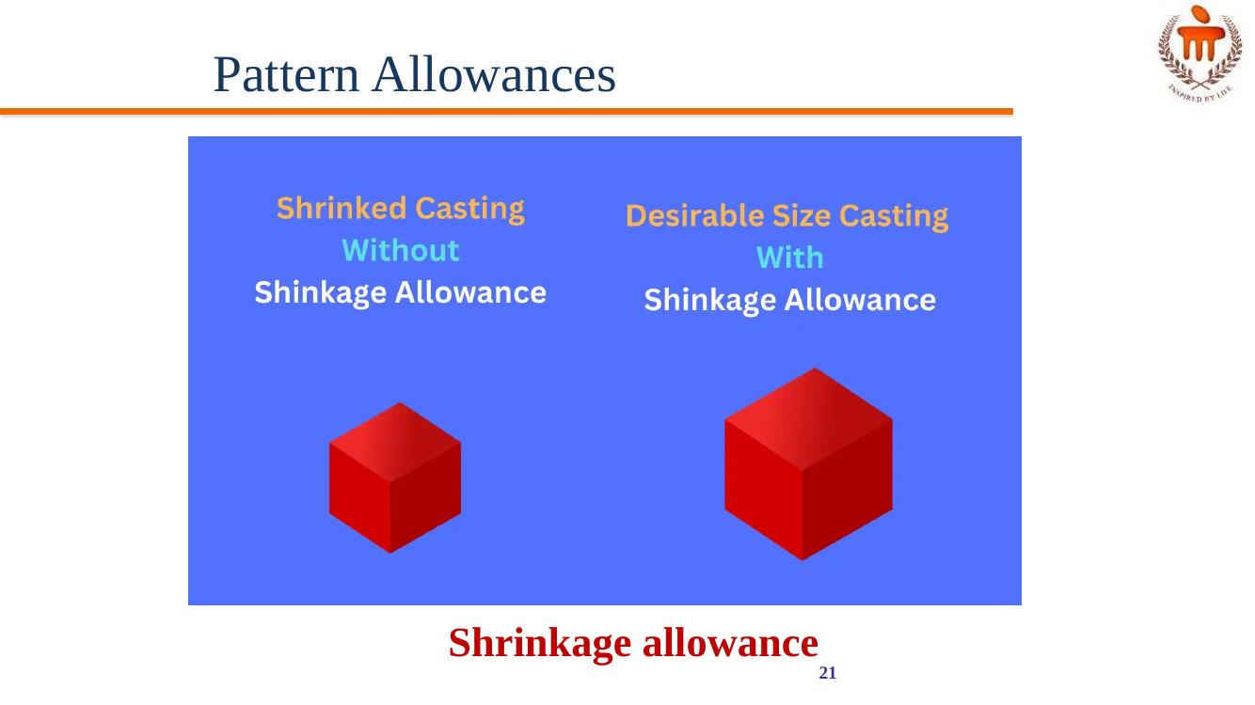
Figure: Shrinkage allowance

2. Machining Allowance
- Given on the surface of the pattern by increasing the metal thickness there, to compensate for loss of metal due to machining on these surfaces
- Depends mainly on the method of machining to be employed
- Given in addition to the shrinkage allowance
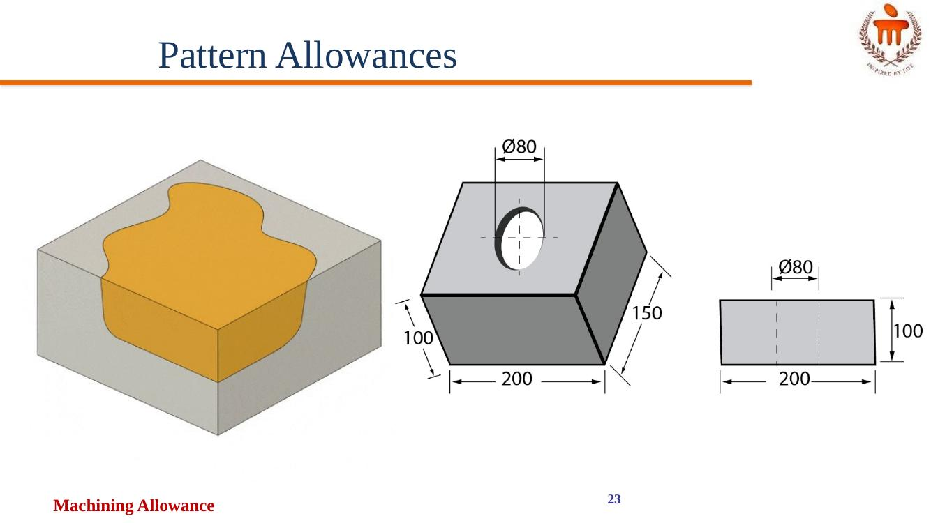
Figure: Machining allowance

3. Draft or Taper Allowance
- A slight taper is given on the vertical surfaces of the pattern, parallel to the direction of withdrawal from the mould
- Provided on both internal and external surfaces
- For easy withdrawal of the pattern from the mould
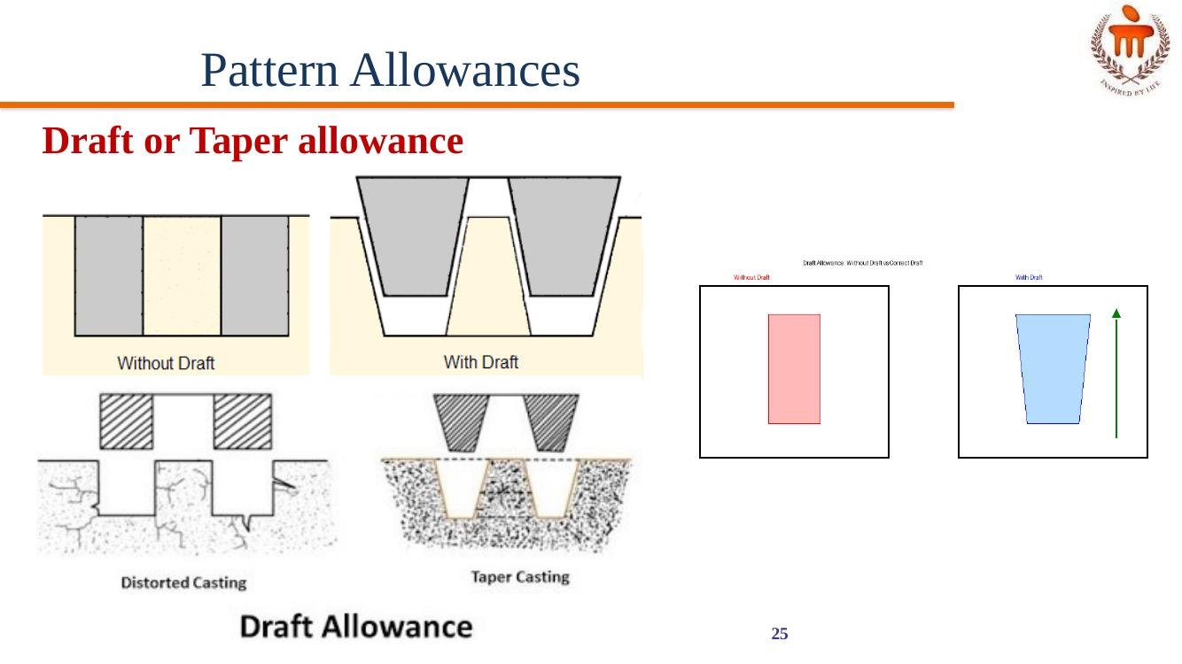
Figure: Draft/taper allowance — without draft vs with draft

4. Rapping (Shake) Allowance
- A negative allowance to be provided in the pattern
- When the pattern is withdrawn from the mould by striking (rapping) it from side to side, the size of the cavity increases
- To compensate for this, rapping allowance is provided

5. Distortion Allowance
- Castings having an irregular shape will not have uniform contraction during cooling, resulting in distortion of the casting
- Remedy: an opposite distortion is provided in the pattern
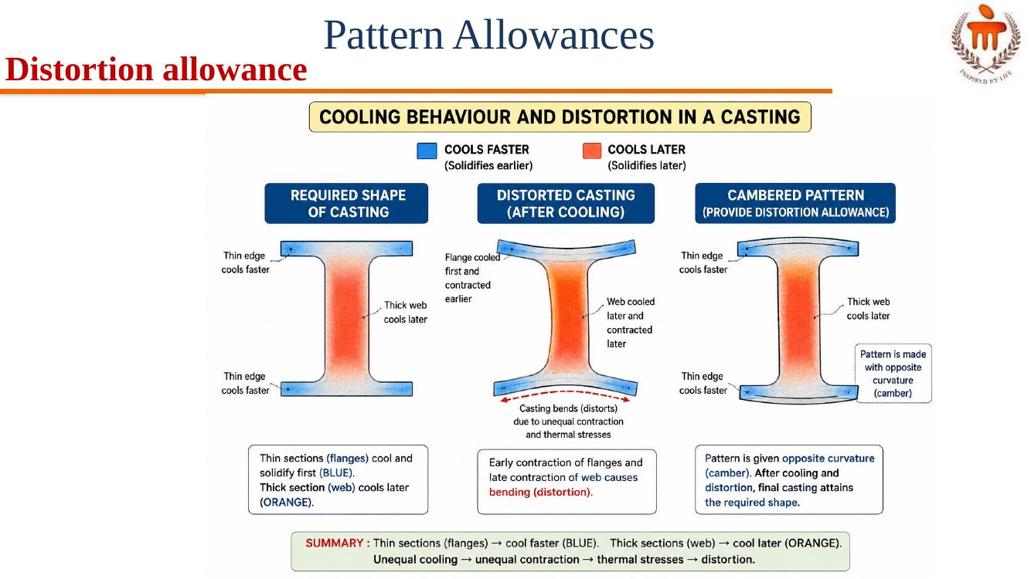
Figure: Cooling behaviour and distortion allowance (camber)

⚡ WARM — Pattern
A pattern is a replica of a casting to be made. Using a pattern, impressions (mould cavity) can be formed in the damp sand to make a mould.

Pattern Materials
- Wood: easy to work and readily available; can be cut into required shapes; used when a small number of castings are needed
- Metal: does not change shape when subjected to moist conditions; used for a small number of castings
- Plastics: do not absorb moisture; smooth; can be withdrawn from the mould easily without damaging the mould
- Plaster: high compressive strength

Types of Patterns
- Single piece pattern
- Match plate pattern
- Gated pattern
- Split pattern
- Cope & Drag pattern
- Loose-piece pattern
- Skeleton pattern

Description of Pattern Types
- Single piece pattern: made from one piece and does not contain loose pieces; inexpensive and of the simplest type
- Split pattern: most widely used pattern for intricate castings; the pattern is split into two parts so that one part is in the cope and the other in the drag; the two halves are aligned properly using dowel pins
- Cope and Drag pattern: similar to split patterns; the cope and drag halves of the pattern, along with the gating and riser systems, are prepared separately and attached to the metal or wooden plate along with alignment pins
- Match plate pattern: an extension of the cope and drag pattern; the cope and drag patterns, along with the gating and risering, are mounted on a single matching (metal) plate on either side
- Loose piece pattern: used when the contour of the part is such that withdrawing the pattern from the mould is not possible; the obstructing part is held as a loose piece
- Skeleton pattern: made of strips of wood for preparing the final pattern by pouring sand around the pattern and packing it
- Gated pattern: usually made of metal, which increases strength and reduces tendency to warp; the section connecting different patterns serves as runner and gates; a gated pattern can manufacture many castings at one time; used in mass production systems
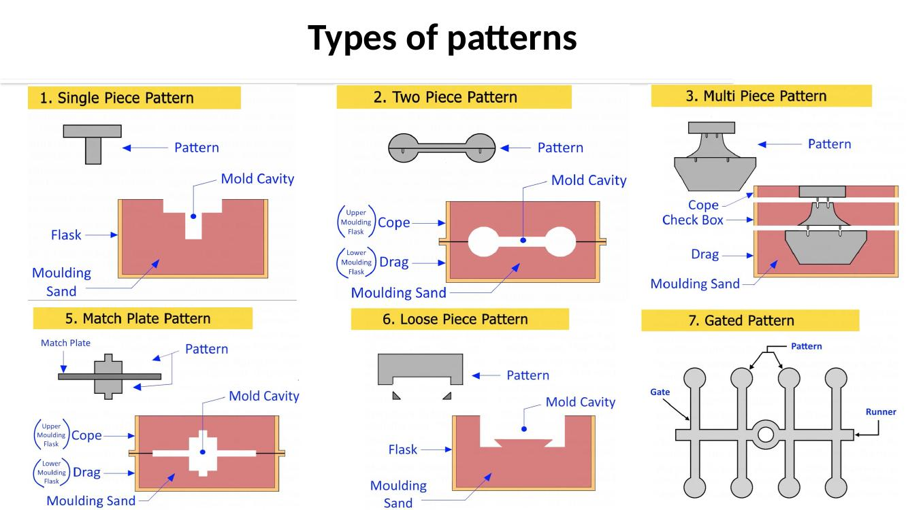
Figure: Types of patterns

⚡ WARM — Complete Mould Assembly (Cross-Section)
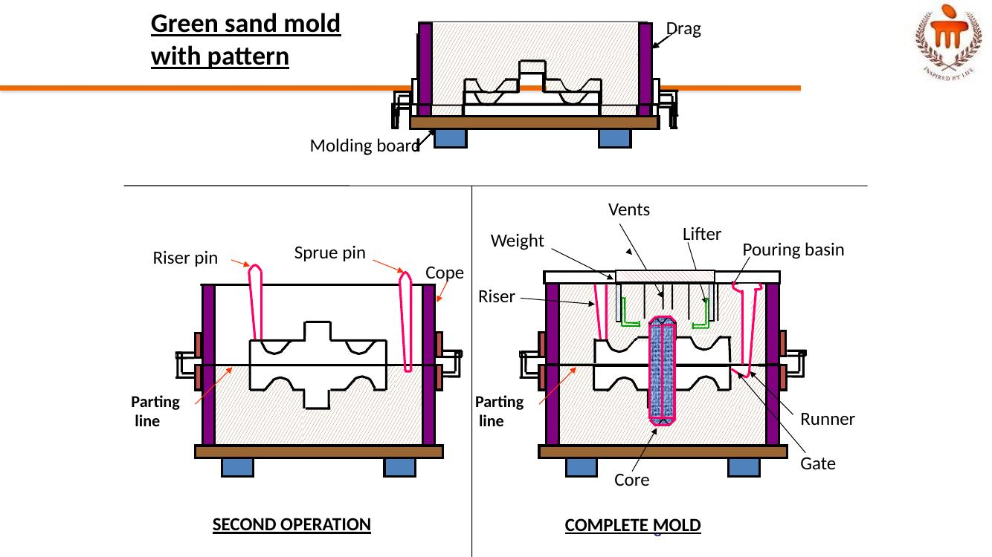
Figure: Green sand mould with pattern — first operation, second operation, and complete mould

💧 POSSIBLE — Casting
Casting is the process of producing metallic parts by pouring molten metal into the mould and allowing the metal to solidify.

💧 POSSIBLE — Casting Process (sequence of steps)
- Mould is prepared
- Metal is heated above melting point temperature
- Liquid metal is poured into the mould
- Metal solidifies into the shape of the mould
- Casted part is removed from the mould
- Post-casting operations: Cutting, Clean up, Machining

Lecture 3 – Moulding Sand

🔥 HOT — Properties of a Moulding Sand
- Porosity (Permeability): sand must be porous to allow gases/moisture present within the mould to be removed freely when molten metal is poured
- Adhesiveness: sand particles must be capable of adhering to the sides of moulding boxes
- Cohesiveness / Strength: ability of sand particles to stick together; must be sufficient to permit the mould to be formed to the desired shape even after hot metal is poured in
- Refractoriness: moulding sands with poor refractoriness may burn onto the casting; measured by the sinter point of sand
- Collapsibility: mould made of sand should collapse as the molten metal solidifies in it
- Flowability: ability of the sand to behave like a fluid so that, when rammed, sand flows to all portions of the mould and around the pattern, taking up the required shape; increases as clay and water content increase; high flowability is required for uniform density and a good impression of the pattern

⚡ WARM — Classification of Moulding Sand
- Natural moulding sand (Green sand): taken from river-beds and contains a major amount of clay; easily available at low cost
- Synthetic sand: contains little or no binder (clay); strength and bonding property can be easily controlled; more expensive than natural sand
- Special sand: ideal for obtaining special characteristics

Types of Moulding Sand (by use)
- Green Sand: contains silica sand, clay, and water; possesses good strength and permeability
- Dry Sand: stronger and more thermally stable than green sand; used for larger, heavier castings
- Loam Sand: a mixture with high clay content (around 50%); used for large castings with skeleton patterns
- Facing Sand: used to form the mould face, providing a smooth surface for the casting and preventing metal penetration
- Backing Sand: supports the facing sand and fills the rest of the mould cavity; contains permeability
- System Sand: applied in machine moulding; possesses high strength, permeability, and refractoriness
- Core Sand: used to make cores; includes binders such as linseed oil, phenol-formaldehyde, urea-formaldehyde, dextrin, starch, sodium silicate, and fire clay
- Parting Sand: used to prevent sand from sticking together at the parting line of the mould

⚡ WARM — Key Components of Sand
- Silica Sand: the base material of the mould (typically silica sand)
- Clay: binds the sand particles together, providing strength and durability to the mould (e.g., bentonite, kaolinite)
- Water: essential for the binding properties of clay in green sand
- Binders (Resins): used in dry sand or resin sand casting to create a strong, solid mould, e.g., phenolic resins, furan resins, urea resins, epoxy resins, acrylic resins
- Auxiliary Substances: may include sawdust, coal powder, or straw, improving air permeability and heat resistance of the mould

Typical Composition Ranges
- Silica sand (SiO2): primary mould material, provides refractoriness; typical range 80–92%
- Clay: acts as a binder; common types include bentonite clay (e.g., sodium bentonite); typical range 6–12%
- Water: activates the clay binder, enabling it to hold sand grains together; typical range 3–6%
- Other additives: include sea coal, silica flour, and other organic materials; improve flowability, permeability of the mould, and surface finish of the casting

💧 POSSIBLE — Green Sand Mould – Key Parts (as illustrated)
- Drag, Cope, Pattern, Molding board
- Vents, Lifter, Weight
- Pouring basin, Sprue pin, Riser pin, Riser
- Parting line, Runner, Gate, Core

💧 POSSIBLE — Molding Tools
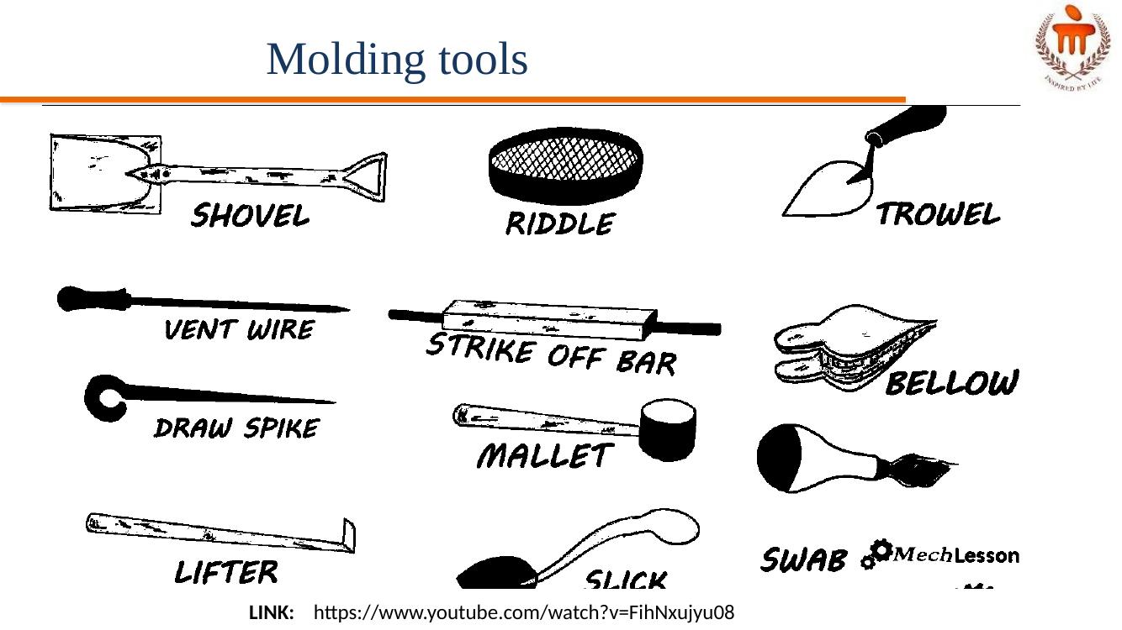
Figure: Common moulding tools — shovel, riddle, trowel, vent wire, strike-off bar, bellow, draw spike, mallet, lifter, slick, swab
Reference video link provided in lecture: https://www.youtube.com/watch?v=FihNxujyu08

💧 POSSIBLE — Sand Preparation
- Very few natural sands have all the qualities required by a moulding sand
- It is mixed with other sands that possess the required characteristics
- Sufficient moisture must be added to the sand
- Sand must be properly conditioned before use

Lecture 4 – Molding and Core Making

⚡ WARM — Green Sand Molding Steps
- The first step is to place the pattern on the molding board
- The drag is placed on the board
- Dry facing sand is sprinkled over the board and pattern to provide a non-sticky layer
- Molding sand is riddled in to cover the pattern with the fingers; then the drag is completely filled
- The sand is firmly packed in the drag by means of hand rammers; ramming must be proper — neither too hard nor too soft
- After ramming, excess sand is leveled off with a straight bar known as a strike-off bar
- With the help of a vent rod, vent holes are made in the drag to facilitate removal of gases during pouring and solidification
- The finished drag flask is rolled over to the bottom board, exposing the pattern
- The cope half of the pattern is placed over the drag pattern with the help of locating pins; the cope flask on the drag is located, aligning again with pins
- Dry parting sand is sprinkled all over the drag and on the pattern
- A sprue pin for making the sprue passage is located at a small distance from the pattern; a riser pin, if required, is also placed at an appropriate place
- Filling, ramming, and venting of the cope proceed in the same manner as performed in the drag
- The sprue and riser pins are removed first, and a pouring basin is scooped out at the top to pour the liquid metal
- The pattern from the cope and drag is removed; facing sand in the form of paste is applied, if required, all over the mould cavity and runners to give the finished casting a good surface finish
- The mould is now assembled and ready for pouring

⚡ WARM — Core Making Steps
- Selection of Sand: properties of core sand are highly crucial and required to have characteristics like permeability, green strength, refractoriness, flowability, collapsibility, adhesiveness, cohesiveness, and dry strength
- Mixing of sand with additives: after thorough mixing of sand, binder is added to the silica sand with moisture content and other additives like coal dust, dextrin, or silica flour to create a mixture
- Blowing or Shooting: mixture is blown into the core box (core shooting process); modern foundries use dedicated core blowing/shooting machines for optimal production
- Venting: essential to provide a venting passage for gases, as trapped gases can result in casting defects; additional venting holes are made in cores to obtain good permeability
- Reinforcement of Cores: heavy and large cores in particular might need additional reinforcement material like cast iron grids or low-carbon steel wires to maintain coherence
- Baking of Cores: to obtain strength, baking of sand cores is done in a conventional oven at temperature between 200°C to 250°C (392°F to 482°F); the heat causes the binder to polymerize
- Cleaning & Finishing: after baking — Trimming (removing loose pieces and unwanted projections), Brushing (removes loose sand off the core with a fine wire brush), Coating (crucial step for finishing; coating cores with refractory material to improve heat resistance)
- Inspection: manual or machine inspection of cores for dimensional accuracy
- Assembling: assembling of multiple cores together with core glue and placement of core in mould
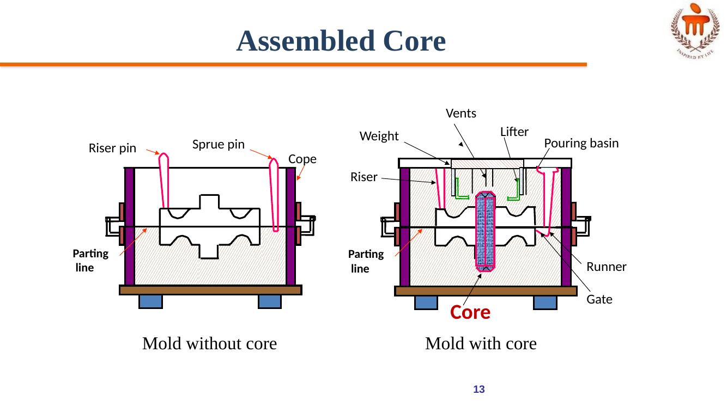
Figure: Mould without core vs mould with core (assembled core)

⚡ WARM — Core
A core is a specialized insert, typically made of sand, that creates hollow spaces or intricate internal features within a cast part. Cores are used to form internal cavities, recesses, undercuts, and other features in castings that the mould itself cannot create. Cores are crucial for producing a wide variety of cast components, from engine blocks with internal cooling passages to more complex shapes with internal features.

💧 POSSIBLE — Conventional Molding Process: Green Sand Molding
Green sand is the most diversified molding method used in metal casting operations. The process utilizes a mould made of compressed or compacted moist sand. The term "green" denotes the presence of moisture in the molding sand. The mould material consists of silica sand mixed with a suitable bonding agent (usually clay) and moisture.

Advantages
- Most metals can be cast by this method
- Pattern costs and material costs are relatively low
- No limitation with respect to size of casting and type of metal or alloy used

Disadvantages
- Surface finish of the castings obtained by this process is not good; machining is often required to achieve the finished product

Lecture 5 – Gating System

🔥 HOT — Gating System Parts
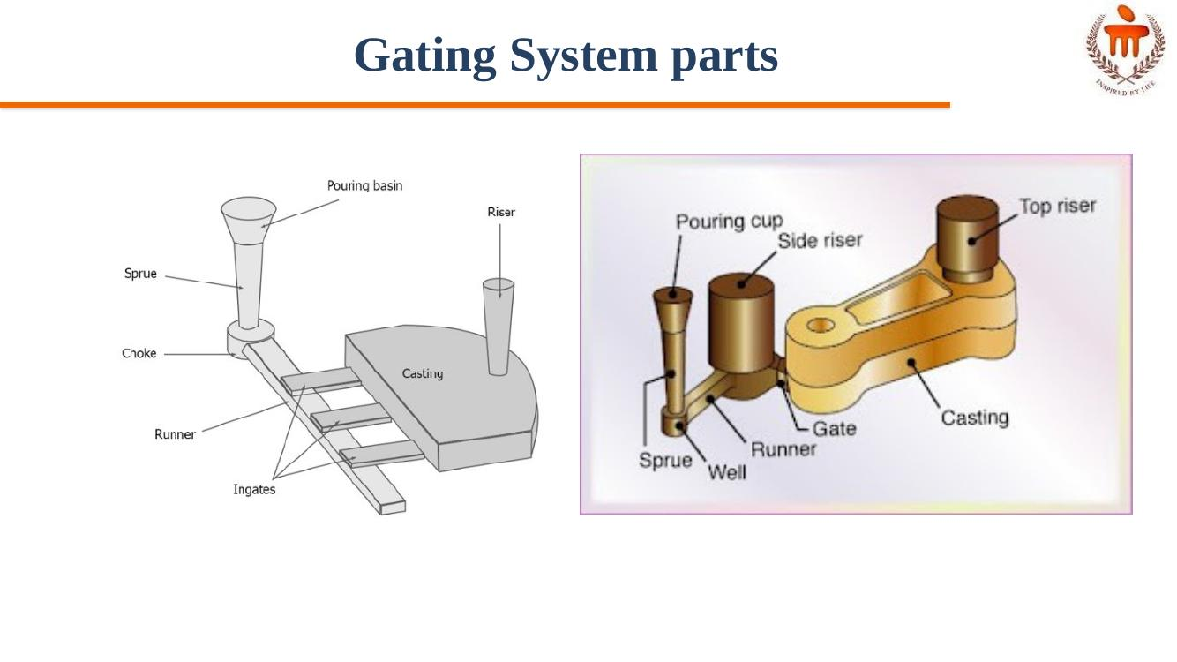
Figure: Gating system parts — pouring basin/cup, sprue, sprue well, runner, gate, riser
- Pouring Basin: a funnel-shaped reservoir at the top of the mould (sprue hole) where molten metal is initially poured from the crucible
- Sprue: the vertical channel that connects the pouring basin to the runner system and controls the flow rate of the metal
- Sprue Well: a small reservoir at the bottom of the sprue, which regulates the flow of metal into the runner and reduces turbulence
- Runner: the horizontal channel(s) that distribute molten metal from the sprue to the gates
- Runner Extension: an elongated part of the runner, used to feed multiple gates or as a collection place for impurities
- In-gate (or Gate): end opening through which molten metal enters the mould cavity

🔥 HOT — Requirements of Gating System
- A good gating design should ensure proper distribution of molten metal without excessive temperature loss, turbulence, gas entrapment, and slags
- Slow pouring increases filling time, leading to premature solidification; hence super heating of metal is required, but this may cause solubility issues
- Faster pouring of molten metal causes erosion of the mould cavity
- Gating design is important and depends on the metal and molten metal composition — for example, aluminium can get oxidized easily

⚡ WARM — Riser
- Riser acts as a metal reservoir which holds extra molten metal, ensuring flow of metal into the mould cavity as the casting material shrinks
- Riser should be the last part of the mould to solidify, ensuring continuous feeding of metal until the complete casting has solidified
- Provides shrinkage compensation of molten metal, without which shrinkage would create voids or porosity within the casting
- Prevents defects by preventing shrinkage cavities and maintaining the desired shape and dimensions

⚡ WARM — Functions of Gating System
- Controlling flow: gates regulate the rate at which molten metal enters the mould cavity, preventing turbulence and ensuring smooth, consistent flow
- Minimizing defects: by controlling flow, gates help prevent issues like air entrapment, shrinkage, and porosity
- Directing metal flow: gates can be strategically placed to guide molten metal to specific areas of the mould, ensuring proper filling of complex shapes
- Shrinkage control: in some cases, gates are designed to act as risers, providing a reservoir of molten metal to compensate for shrinkage during solidification

💧 POSSIBLE — Types of Gates
- Top Gate: molten metal enters the mould cavity from the top; simple but can cause turbulence and erosion
- Bottom Gate: molten metal enters the mould cavity from the bottom; can lead to temperature variations within the casting, with the bottom being hotter and the top cooler
- Parting Line Gate: molten metal enters the mould cavity at the parting line, where the two halves of the mould meet; simple and cost-effective, but prone to erosion and dross formation
- Step Gate: used in the sand casting process for producing heavy castings of large size; used when the molten metal requirement is large and metal needs to fill the mould cavity in steps

💧 POSSIBLE — Gating System
A gate is a specific part of the gating system, acting as the entry point for molten metal into the mould cavity. It is designed to control the flow rate and direction of the molten metal as it enters the mould. Gates can be designed in various shapes and sizes, depending on the casting process, material, and desired part characteristics. The gate's design and placement are crucial for achieving a sound and defect-free casting.

💧 POSSIBLE — Aspiration Effect
Aspiration effect: entering of gases from baking of organic compounds present in the mould into the molten metal stream, producing porous castings. Pressure anywhere in the liquid stream should not become negative.

Lecture 6 – Die Casting and Centrifugal Casting

🔥 HOT — Centrifugal Casting
Centrifugal casting is a metal casting process that utilizes centrifugal force to distribute molten metal into a rotating mould, producing cylindrical or symmetrical parts. This method is particularly effective for creating pipes, tubes, and other components with rotational symmetry, leveraging the force of rotation to ensure uniform metal distribution and potentially reduced defects.

Process
- Molten metal is introduced into a rotating metal, or graphite mould, and held against the mould wall by centrifugal force until it solidifies
- A mould is set up and rotated along a vertical axis (reasonable rpm), or horizontal axis (200–1000 rpm is reasonable)
- The mould is coated with a refractory coating
- During cooling, lower density impurities will tend to rise towards the center of rotation
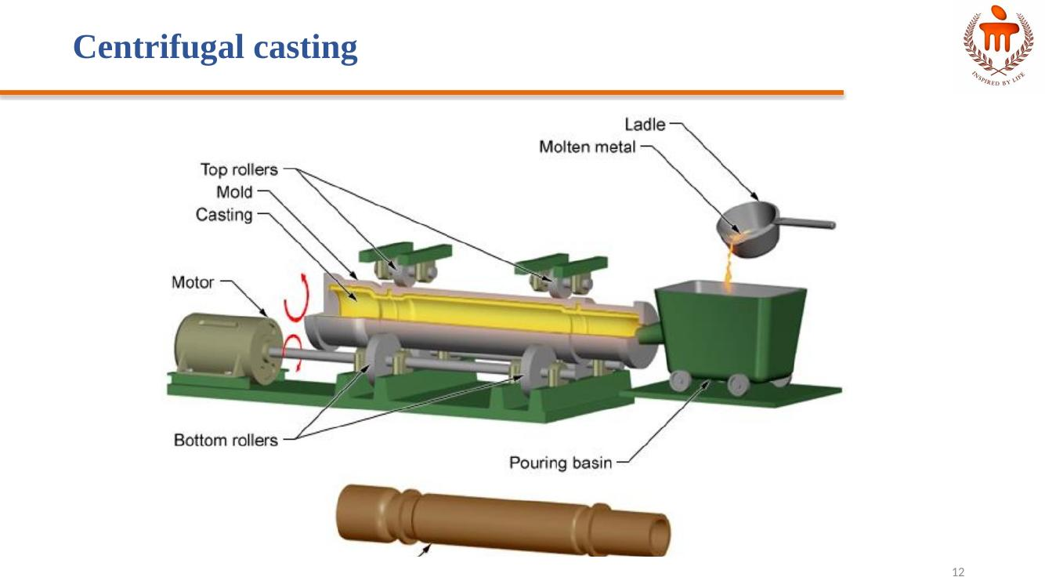
Figure: Centrifugal casting setup

🔥 HOT — Hot Chamber Die Casting
- Good for low temperature metals (approx. 650°C)
- Faster than cold chamber machines
- Cycle times must be short to minimize metal contamination
- Metal starts in a heated cylinder
- A piston forces metal into the die
- The piston retracts and draws metal in
- Metals used: Lead, Tin, Zinc
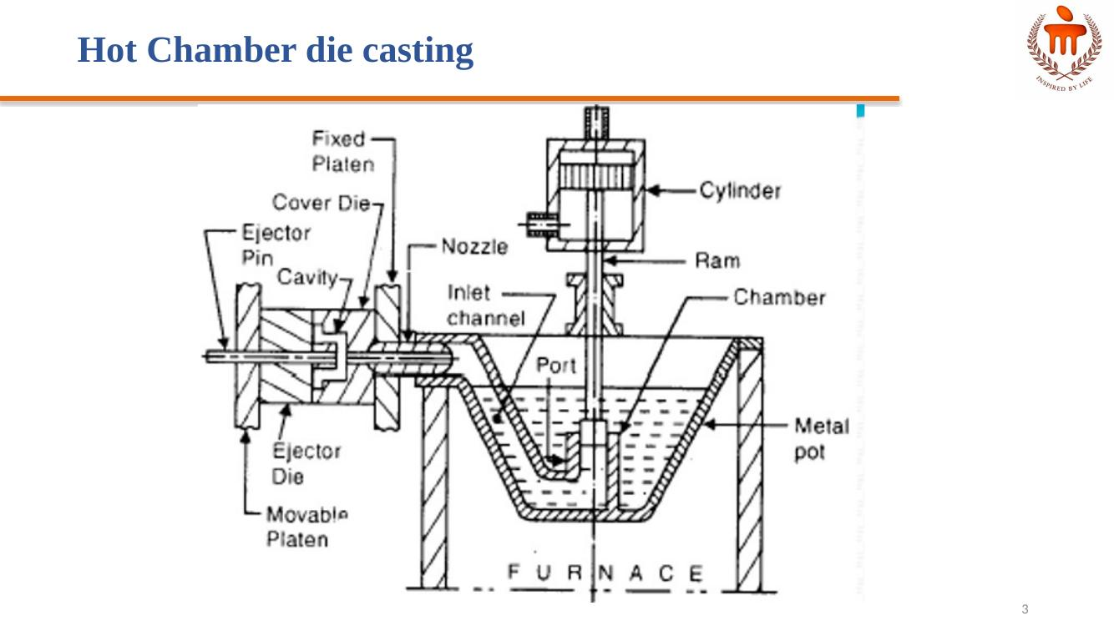
Figure: Hot chamber die casting machine

🔥 HOT — Cold Chamber Die Casting
- Casts high melting point metals (> 700°C)
- High pressures used
- Metal is heated in a separate crucible
- Metal is ladled into a cold chamber
- The metal is rapidly forced into the mould before it cools
- Copper, Brass, and Aluminum can be cast
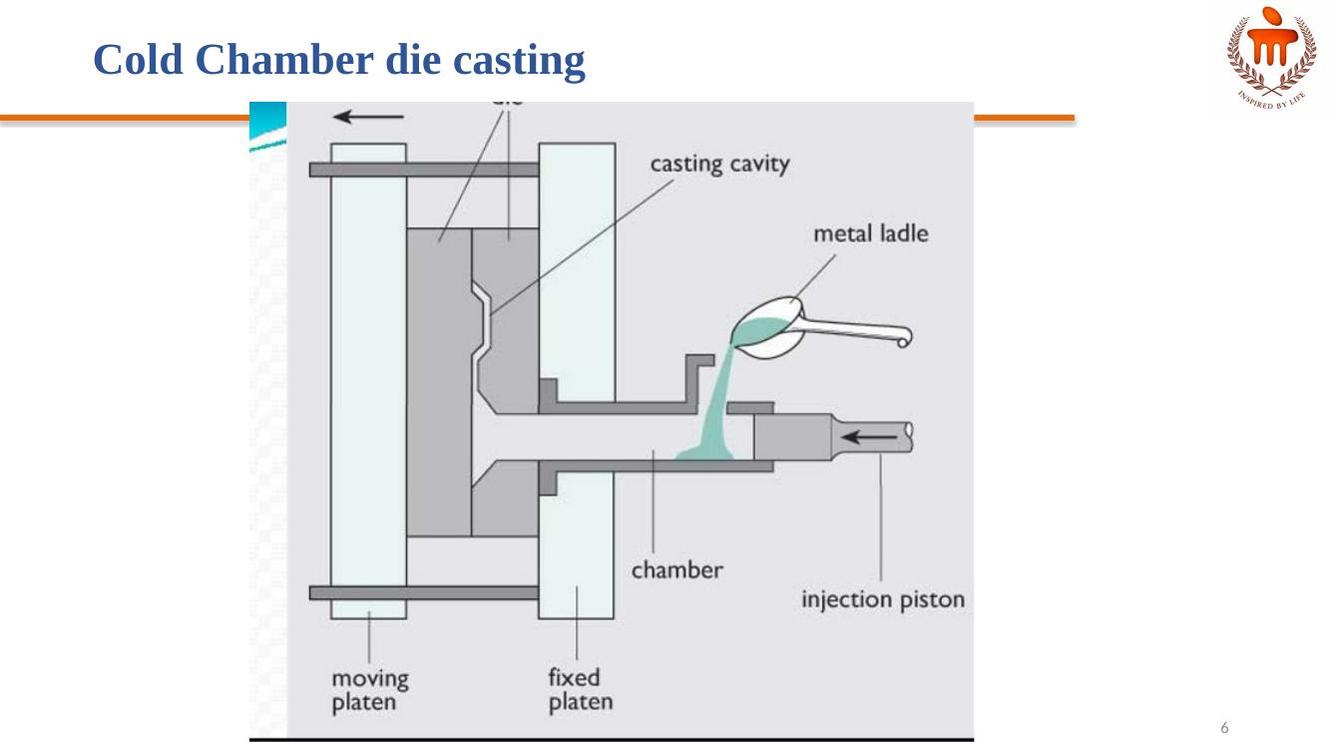
Figure: Cold chamber die casting machine

Characteristics of Cold Chamber Die Casting
- Extremely smooth surfaces (1 µm)
- Excellent dimensional accuracy
- Rapid production rate
- Better mechanical properties compared to sand casting
- Intricate parts possible

Summary Table: Hot Chamber vs Cold Chamber Die Casting
Parameter | Hot Chamber | Cold Chamber
Materials | Zinc, Magnesium | Aluminum, Copper, Brass
Pressure Range | 7–40 MPa | 20–150 MPa
Metal Feeding | Integrated (gooseneck) | Manual ladling
Cycle Time | Faster | Slower
Melting Temp | Low | High

⚡ WARM — Die Casting – General Points
- High initial die cost
- Limited to high-fluidity nonferrous metals
- Part size is limited
- Porosity may be a problem
- Some scrap in sprues, runners, and flash, but this can be directly recycled

Applications
- Carburetors
- Automotive parts
- Bathroom fixtures
- Toys

Common Metals
Alloys of aluminum, zinc, magnesium, and lead. Also possible with alloys of copper and tin.

Lecture 7 – Investment Casting

⚡ WARM — Process Steps
- Pattern creation: wax patterns are typically injection molded into a metal die and formed as one piece (sometimes special designs made); cores may be used to form any internal features on the pattern
- Mold creation: this "pattern tree" is dipped into a slurry of fine ceramic particles, coated with more coarse particles, and then dried to form a ceramic shell around the patterns and gating system; this process is repeated until the shell is thick enough to withstand the pressure of the molten metal it will encounter
- Lost wax: the shell is placed into an oven and the wax is melted out, leaving a hollow ceramic shell that acts as a one-piece mould — hence the name "lost wax" casting
- Pouring: the mould is preheated in a furnace to approximately 1000°C (1832°F) and the molten metal is poured from a ladle into the gating system of the mould, filling the mould cavity
- Cooling: after the mould has been filled, the molten metal is allowed to cool and solidify into the shape of the final casting; cooling time depends on the thickness of the part, thickness of the mould, and the material used
- Casting removal: after the molten metal has cooled, the mould can be broken and the casting removed; the ceramic mould is typically broken using water jets, but several other methods are also used; once removed, the parts are separated from the gating system by sawing, grinding, or cold breaking (using liquid nitrogen)
- Finishing: finishing operations such as grinding or sandblasting are often used to smooth the part at the gates; heat treatment is also sometimes used to harden the final part

⚡ WARM — Investment Casting
Investment casting requires the use of a metal die, wax, ceramic slurry, furnace, molten metal, and any machines needed for sandblasting, cutting, or grinding. Investment casting, also known as lost-wax casting, is a versatile manufacturing process used across numerous industries to create intricate, high-precision parts. It is particularly well-suited for applications requiring complex geometries, tight tolerances, and smooth surface finishes.
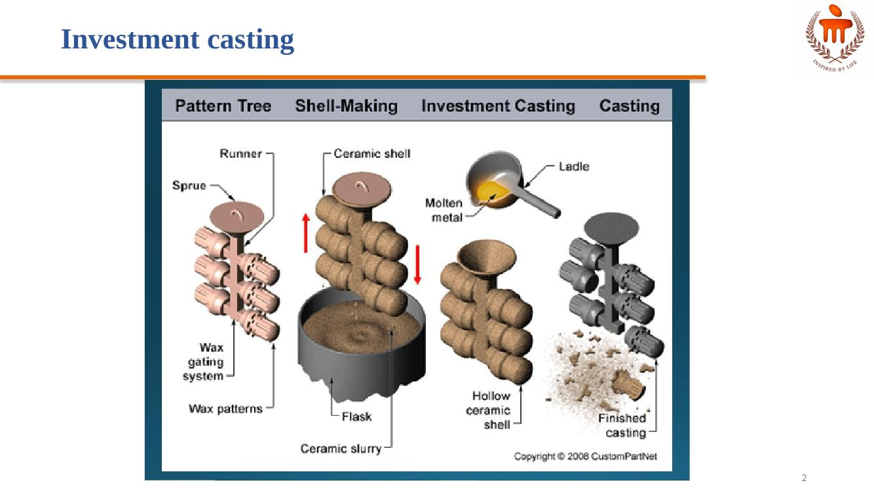
Figure: Investment casting process — pattern tree, shell-making, casting, finished part

💧 POSSIBLE — Materials and Part Size
Part size (weight): 0.02 oz – 500 lb
Materials: Alloy Steel, Carbon Steel, Stainless Steel, Aluminum, Copper, Nickel, Cast Iron, Lead, Magnesium, Tin, Titanium, Zinc

💧 POSSIBLE — Shapes Achievable
- Thin-walled: Complex shapes
- Solid: Cylindrical
- Solid: Cubic
- Solid: Complex shapes
- Thin-walled: Cylindrical
- Thin-walled: Cubic

Lecture 8 – Welding: Concept and Classification

⚡ WARM — Introduction to Welding
- Welding is a materials joining process in which two or more parts are coalesced at their contacting surfaces by suitable application of heat and/or pressure
- Some welding processes are accomplished only by heat, no pressure required; some require both heat and pressure; some require only pressure, with no external heat
- Some welding processes require filler material to facilitate coalescence
- The assembly of joined parts by welding is called a weldment

⚡ WARM — Classification of Metal Joining Processes
Joining Processes are broadly divided into Mechanical Bonding and Atomic Bonding (Welding).
- Mechanical Bonding: includes Temporary Joining (screw/nut-bolt) and Permanent Joining; further includes Rivets, Stitches, Staples, Shrink Fit
- Atomic Bonding (Welding): divided into Solid State welding, Liquid State (Fusion) Welding, and Liquid/Solid welding
- Solid State welding: includes Cold Welding, Friction Welding, Diffusion Welding, Hot Forge Welding
- Liquid/Solid welding: includes Brazing, Soldering, and Adhesive Bonding
- Liquid State (Fusion) Welding: divided by energy source into Electrical Energy and Chemical Energy
- Fusion welding – Electrical Energy: SMAW (Shielded Metal Arc Welding), Induction Welding, Resistance Welding, GMAW (Gas Metal Arc Welding), LBW (Laser Beam Welding), EBW (Electron Beam Welding), GTAW (Gas Tungsten Arc Welding)
- Fusion welding – Chemical Energy: Gas Welding, Thermit Welding
- Resistance Welding sub-types: Spot, Seam, Projection, Flash Butt, Upset Butt
- Other processes noted: Cold Welding, Ultrasonic Welding, Pressure Welding, Explosive Welding
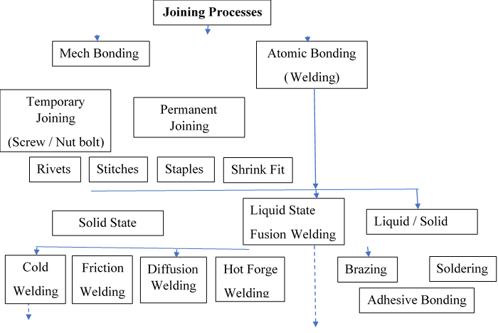
Figure: Classification of joining processes — mechanical bonding vs atomic bonding (welding)
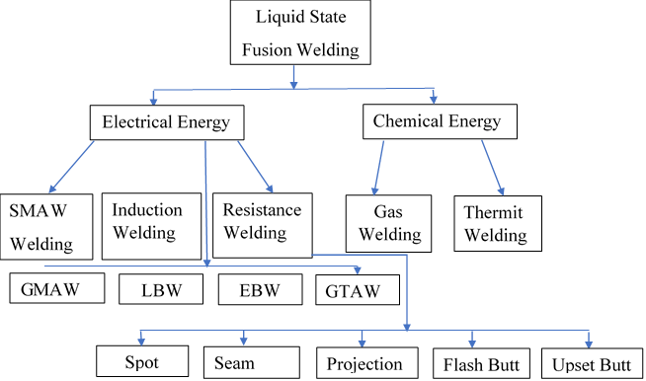
Figure: Classification of liquid-state (fusion) welding by energy source

⚡ WARM — Welding Defects
Common welding defects: Slag Inclusion, Undercut, Porosity, Incomplete fusion, Weld overlap, Underfill, Weld Spatter, Incomplete weld penetration.

Undercut
- Causes: high current, improper electrode angle, long arc length
- Elimination: appropriate current, training to operator
- Repair: use smaller electrode

Slag Inclusion
- Causes: insufficient current, slow travel speed
- Elimination: proper current, appropriate travel speed
- Repair: removed by grinding

Porosity
- Causes: release of trapped gases
- Elimination: cleaning of the surface and ends
- Repair: removed by grinding

Incomplete Fusion
- Causes: low current, fast travel speed, short arc gap
- Elimination: appropriate current and travel speed
- Repair: remove and reweld

Weld Overlap
- Causes: untrained operator, steep electrode angle, faster travel speed
- Elimination: appropriate welding technique
- Repair: removed by grinding

Underfill
- Causes: faster travel speed, improper welding technique
- Elimination: use stripper beads before cover pass
- Repair: clean and fill by welding

Weld Spatter
- Causes: high arc current, magnetic arc blow
- Elimination: reduce arc current, shorten arc length
- Repair: removed by grinding

Incomplete Weld Penetration
- Causes: low current, fast travel speed, short arc length
- Elimination: appropriate current, travel speed, and electrode
- Repair: clean and reweld

💧 POSSIBLE — Zones at the Weld Area
- Fusion zone: consists of a mixture of filler metal and base metal that have completely melted; characterized by a high degree of homogeneity among the component metals melted during welding
- Weld interface zone: a narrow boundary that separates the fusion zone from the heat-affected zone; consists of a thin band of base metal that was melted or partially melted (localized melting within the grains) during welding but then immediately solidified before mixing with the metal in the fusion zone
- Heat-affected zone (HAZ): the metal in this zone has experienced temperatures below its melting point, yet high enough to cause microstructural changes in the solid metal
(Diagram order across the joint: Unaffected base metal zone → Heat-affected zone (HAZ) → Weld interface → Fusion zone)
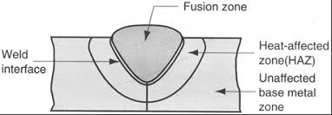
Figure: Zones at the weld area

💧 POSSIBLE — Types of Welding Joints
There are five basic types of joints for bringing two parts together for joining:
- Butt joint: the parts lie in the same plane and are joined at their edges
- Corner joint: the parts form a right angle and are joined at the corner of the angle
- Lap joint: consists of two overlapping parts
- Tee joint: one part is perpendicular to the other in the approximate shape of the letter "T"
- Edge joint: the parts are parallel with at least one of their edges in common, and the joint is made at the common edge(s)
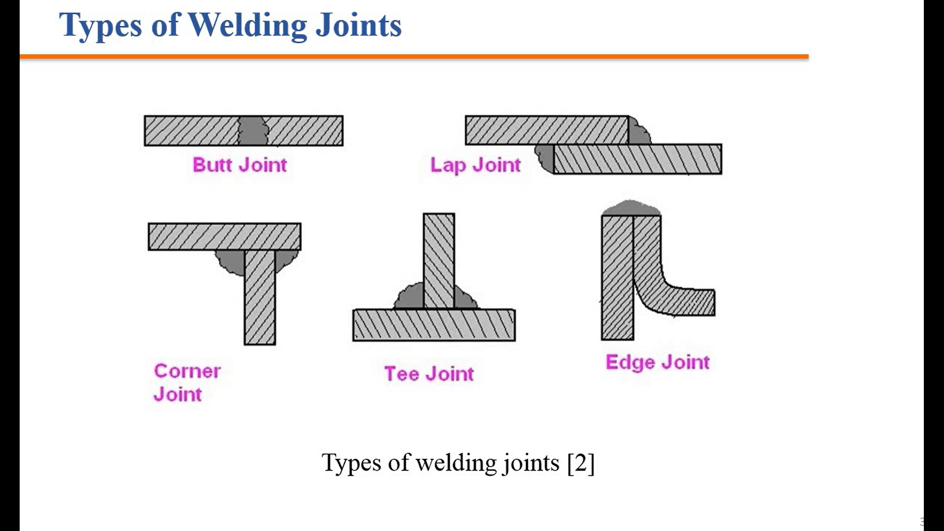
Figure: Types of welding joints — butt, lap, corner, tee, edge

💧 POSSIBLE — Sources of Energy in Welding Processes
- Chemical energy: Gas welding, explosive welding, Thermit welding
- Mechanical energy: Friction welding, Ultrasonic welding
- Electrical energy: Arc welding, Resistance welding
- Radiation energy: Laser beam welding, Electron beam welding

References (as given in lecture)
- Ghosh, A. & Mallik, A.K.; Joining processes, Manufacturing Science, Latest edition.
- https://fractory.com/heat-affected-zone-causes-effects-reduction/
- Kalpakjian, S & Schmid, S.; Manufacturing Processes for Engineering Materials, Latest edition.

Lecture 9 – Gas Welding and Types of Flame

🔥 HOT — Types of Gas Welding Flames

Neutral Flame
When equal amounts of oxygen and acetylene are mixed and burnt at the outlet of the welding torch, a neutral flame is obtained. This type of flame is made of two sharply defined zones, i.e., an inner white flame cone and an outer envelope of blue colour.

Carburizing Flame
Consists of three zones: the inner cone, an outer envelope (as in the neutral flame), and a middle zone surrounding the inner cone extended to the outer envelope. Its size increases with increased quantity of acetylene.

Oxidizing Flame
Produced by an excess amount of oxygen in the mixture. The oxygen-to-acetylene ratio varies between 1.15 and 1.50. The inner cone is relatively shorter, and excess oxygen turns the flame to a light blue colour. It burns with a harsh sound.
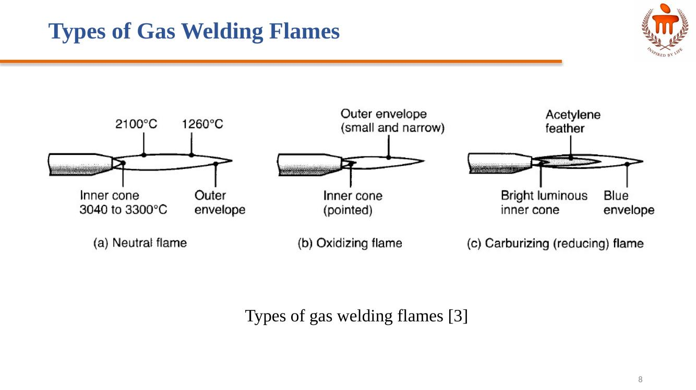
Figure: Types of gas welding flames — neutral, oxidizing, carburizing (reducing)

⚡ WARM — Oxy-Acetylene Gas Welding
In oxy-acetylene welding, heat is generated as a result of a chemical reaction. The primary combustion process occurs in the inner core of the flame and involves the following reaction:
2CO + H₂ + 1.5 O₂ → 2CO₂ + H₂O + Heat
This reaction consists of the further burning of both the hydrogen and the carbon monoxide, and produces about two-thirds of the total heat. The temperature developed in the flame is approximately 3300°C.

⚡ WARM — Gas Welding Equipment
- Gas cylinders
- Hose pipes and valves
- Cylinder pressure gauge
- Outlet pressure gauge
- Pressure regulators
- Blow pipe or torch and spark lighter
- Welding screens & goggles
- Gloves and apron
- Wire brush, trolley, chipping hammer
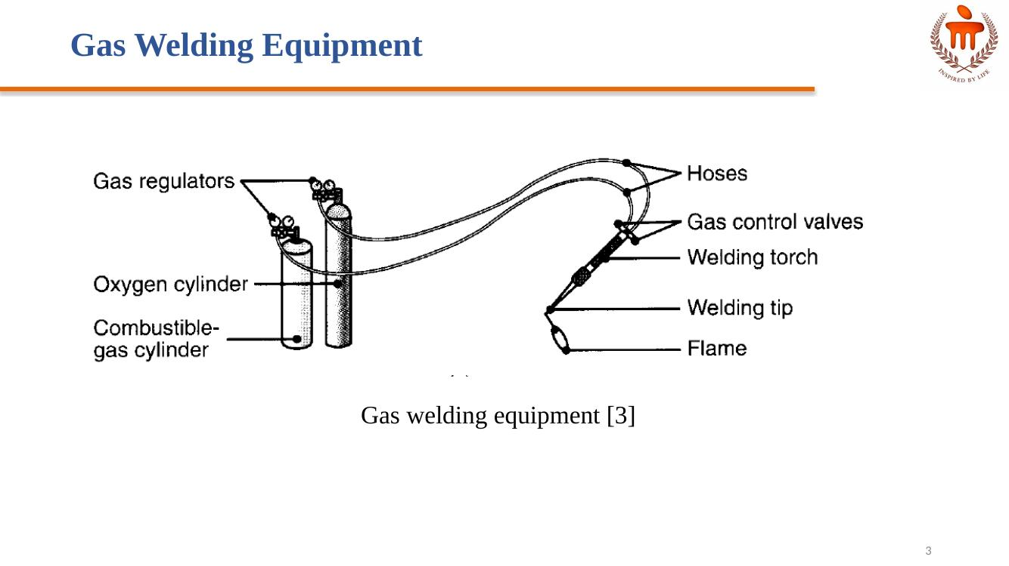
Figure: Gas welding equipment

Gas Cylinders
- Oxygen gas cylinder is painted black colour and acetylene cylinder in maroon or red colour. Oxygen is filled at pressure up to 2000 PSI
- Acetylene is kept dissolved in acetone in the maroon cylinder. For safety reasons, the acetylene cylinder should not be exposed to higher temperatures
- Both cylinders are made with different types of threads (left-hand and right-hand)

Pressure Regulators
Each cylinder is fitted with a pressure regulator that maintains supply pressure at a constant value. Supply pressure can be controlled and maintained at different values as required.

Pressure Gauges
A pressure gauge measures the pressure with respect to atmospheric pressure. Two pressure gauges are mounted on each cylinder — one for cylinder pressure and one for supply pressure.

Hose Pipes & Control Valves
Hose pipes carry gases from their respective cylinders to the blow pipe. Colour codes of hose pipes are the same as the cylinders. Hose pipes are made of good quality rubber for long life. Each cylinder is fitted with valves to control the flow of oxygen and acetylene separately, to obtain the desired flame.

Torch
- Gas welding torches are low-pressure torches; gas cutting torches are high-pressure torches
- Both gases are mixed in a chamber of the torch and then flow out through the nozzle and are burnt by a spark lighter
- Gas cutting torch has holes for flow of the mixture of gases at the periphery and a separate oxygen flow hole at the centre

💧 POSSIBLE — Gas Cutting
- Gas cutting or flame cutting is an exothermic oxidation of the steel being cut
- The material is preheated by an oxy-fuel gas flame around 900°C
- The gas cutting nozzle has an outer ring of holes through which the preheating gas mixture is delivered, and a central hole through which only oxygen gas flows
- The exothermic oxidation of steel forms a fluid slag of iron oxide, and the metal section is pierced. Molten metal is carried away from the cut by the oxygen stream, leaving a cut. Movement of the cutting torch across the workpiece cuts a continuous slot
- Usually, steel sections up to 300 mm thick are easily cut
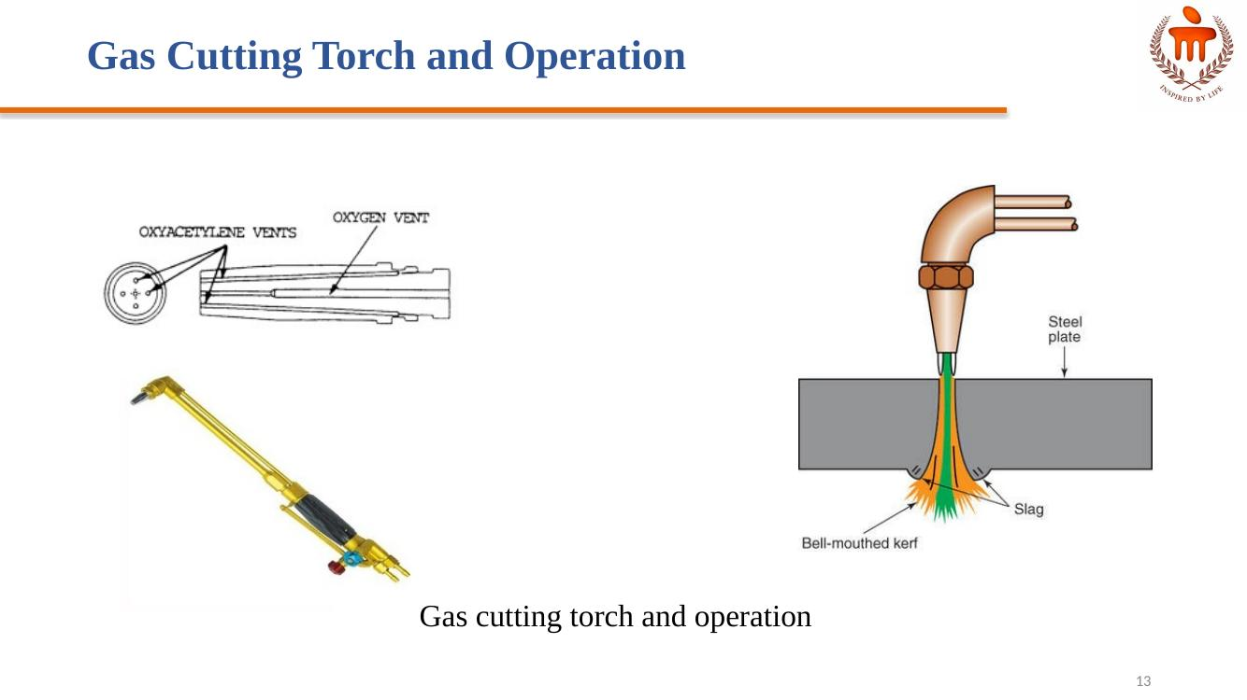
Figure: Gas cutting torch and operation

References (as given in lecture)
- Ghosh, A. & Mallik, A.K.; Joining processes, Manufacturing Science, Latest edition.
- https://www.sciencedirect.com/topics/engineering/gas-welding
- Kalpakjian, S & Schmid, S.; Manufacturing Processes for Engineering Materials, Latest edition.

Lecture 10 – Electric Arc Welding: SMAW and Submerged Arc Welding

🔥 HOT — Submerged Arc Welding (SAW)
- Flux contains calcium oxide, calcium fluoride, and silica sintered to form coarse powder
- Flux powder is spread on the joint to be welded
- Metal electrode is fed into this flux
- Flux melts and covers the weld bead
- AC and DC are used, with current rating 200 to 2000 amps
- Used to weld thick sheets
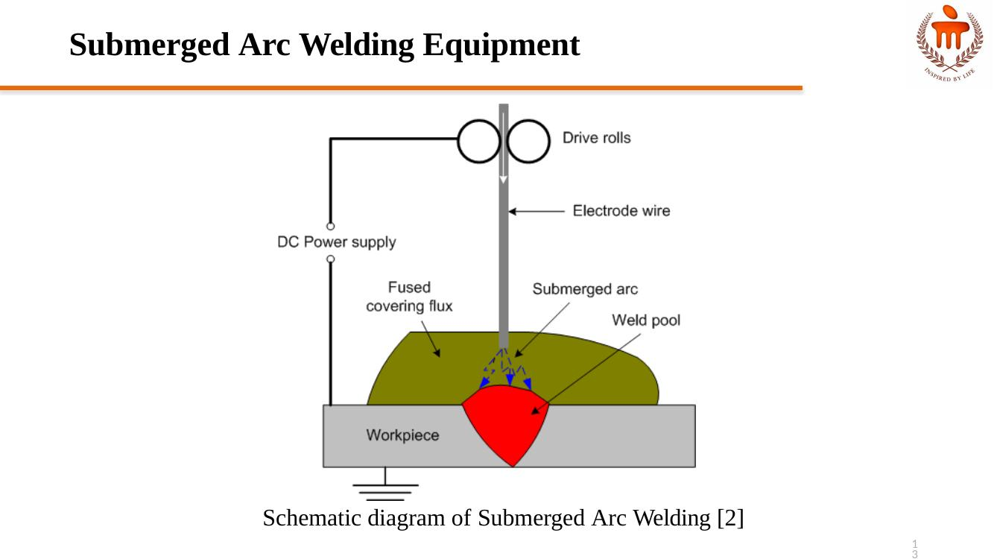
Figure: Schematic diagram of Submerged Arc Welding

⚡ WARM — Arc Welding Equipment
- Welding machine / transformer (AC)
- Electrode holder
- Cables
- Chipping hammer
- Wire brush
- Flux coated electrode
- Welding shields
- Goggles
- Gloves
- Apron

Power Supply
- Both AC and DC are used for welding
- AC machine is a transformer which converts the supply to low voltage and high current; AC is recommended for ferrous metal
- For AC welding, power is required at 80 to 110 volts and 50 to 300 amperes
- For DC welding, normally power is required at 8 to 25 volts and 50 amperes

Polarity in DC Welding
- Straight Polarity: electrode is made the negative pole and workpiece is made the positive pole; two-thirds of the total heat is generated at the positive pole and only one-third at the negative pole
- Reversed Polarity: electrode is made the positive pole and workpiece is made the negative pole; polarity is decided according to the requirement of heat at either pole

⚡ WARM — Arc Welding Electrodes
- Welding electrodes: consumable electrodes and non-consumable electrodes
- Consumable electrodes provide filler metal; they are of two types — coated and bare electrodes
- Bare electrodes are used in case of gas shielded welding
- Additional filler metal is required for non-consumable electrodes (e.g., GTAW)

Coated Electrodes
- Electrode is coated with flux
- Common flux ingredients that help in slag formation: asbestos, mica, silica, fluorspar, titanium dioxide, magnesium oxide, calcium oxide, manganese oxide, alumina, ferrous oxide, calcium fluoride, and silicates of potassium & sodium
- Some ingredients are used as per required properties in the weld
- Ingredients used to produce a reducing atmosphere: cellulose, dolomite, wood flour, starch
- Iron powder provides a higher deposition rate
- Manganese oxide, potassium silicate, and titanate are the alloying elements and stabilizers

Merits of Flux on Electrodes
- Develops reducing atmosphere and prevents oxidation
- Forms separable slag from metal impurities
- Establishes arc stability
- Improves bead appearance
- Avoids weld spatter
- Provides necessary alloying elements to the weld pool

Types of Flux Coating
- Cellulose coating: good penetration; CO and hydrogen generated during the process make the joint brittle
- Rutile coating: more titanium dioxide compared to cellulose coating
- Iron oxide coating: less gas produced, protection by slag
- Basic or low-hydrogen generating content coating: calcium carbonate and calcium fluoride produce CO + CO2; a short arc length is maintained for protection

💧 POSSIBLE — Introduction to Arc Welding
Processes that fall under Arc Welding: SMAW, GTAW, GMAW, Submerged Arc Welding.
SMAW (Shielded Metal Arc Welding) is also known as Manual Arc Welding. It is simple, portable, and inexpensive; suitable for almost all kinds of materials; can be used in hard-to-access areas; and has low initial cost.
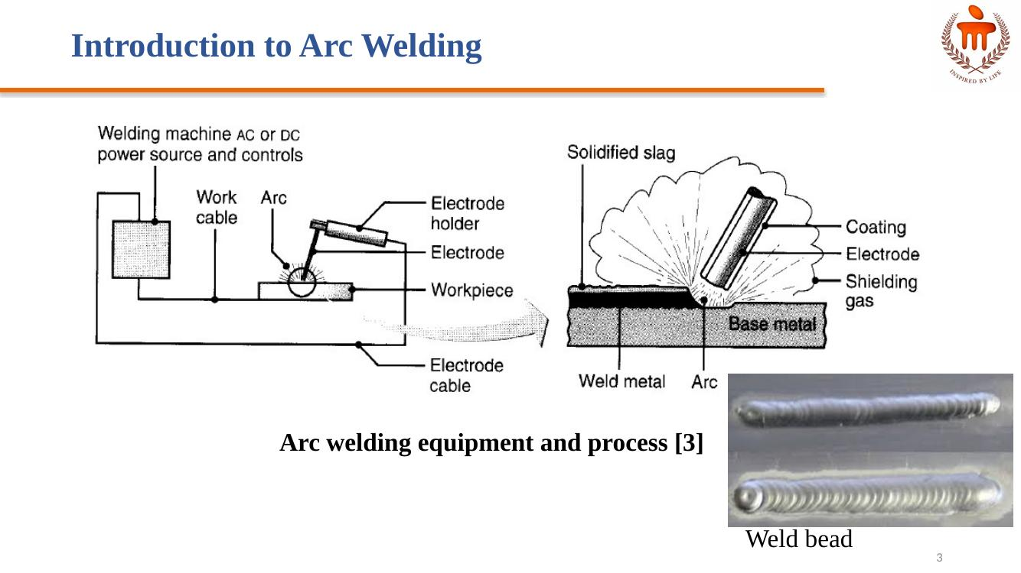
Figure: Arc welding equipment and process, and weld bead

💧 POSSIBLE — Other Welding Equipment
- Connecting Cables: used to connect electrode holder with the power source; flexible enough to facilitate easy movement of the electrode; provided with good insulation coating and can bear high current
- Welding Shield: used for protection of the welder's eyes from ultraviolet radiation, which may cause permanent damage to eyes
- Chipping Hammer: used to remove slag coating and clean the joint

💧 POSSIBLE — Arc Welding Control Parameters
- Work angle
- Travel angle
- Arc length
- Travel speed

References (as given in lecture)
- Ghosh, A. & Mallik, A.K.; Joining processes, Manufacturing Science, Latest edition.
- Lecture 19: https://drive.google.com/file/d/16o4wOavcwCZW9tFDZPvAkRmMzdt_NfeQ/view
- Kalpakjian, S & Schmid, S.; Manufacturing Processes for Engineering Materials, Latest edition.
- Lecture 14 & 15: https://nptel.ac.in/courses/112/107/112107089/

Lecture 11 – Resistance Welding

🔥 HOT — Principle of Resistance Welding
The heat is generated because of electric resistance. Heat is generated when current flows through resistance. The generated heat depends on the material's resistance, applied current, surface conditions, and the applied time period of current. Variants of resistance welding such as spot, seam, projection, flash butt, and upset butt work on this same principle. Pressure is also applied.

🔥 HOT — Flash Butt Welding Process
- Normally used for butt joints; the two surfaces to be joined are brought into contact or near contact, and electric current is applied to heat the surfaces to the melting point, after which the surfaces are forced together to form the weld
- In addition to resistance heating, some arcing occurs (called flashing, hence the name flash welding) between the faying surfaces, so flash welding is sometimes classified in the arc welding group
- Current is usually stopped during upsetting
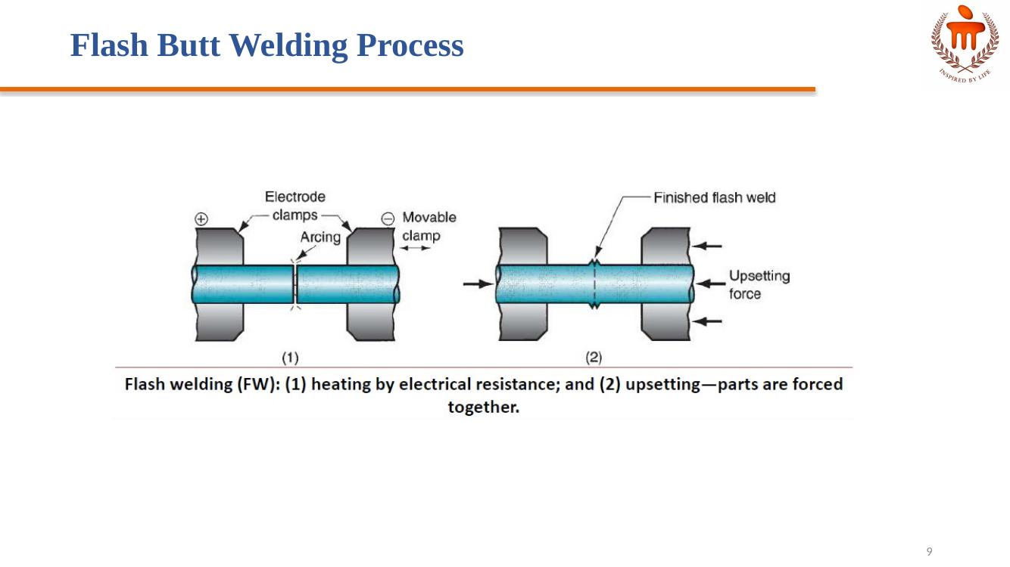
Figure: Flash butt welding — (1) heating by electrical resistance, (2) upsetting

🔥 HOT — Upset Butt Welding Process
- Upset welding (UW) is similar to flash welding, except that in UW the faying surfaces are pressed together during heating and upsetting
- In flash welding, the heating and pressing steps are separated during the cycle
- Heating in UW is accomplished entirely by electrical resistance at the contacting surfaces; no arcing occurs
- When the faying surfaces have been heated to a suitable temperature below the melting point, the force pressing the parts together is increased to cause upsetting and coalescence in the contact region
- Thus, upset welding is not a fusion-welding process in the same sense as the other welding processes discussed

⚡ WARM — Seam Welding Process
- Disk-type electrodes are used
- Produces continuous type of welding between two sheets
- Disks are made of copper, and current is applied through them
- Current is applied in pulse form at time intervals
- Disks rotate continuously so that the metal sheets move forward
- Used to manufacture seam-welded pipes

⚡ WARM — Projection Welding Process
- It is a modification of spot welding; one sheet is provided with projections and the other is plain — the projections are circular in form
- Projection diameter is equal to the thickness of the plate
- Sheets to be welded are kept between electrodes made of copper
- Current and pressure get concentrated at the projection areas during the process
- Pressure is applied by the upper movable electrode; the lower electrode is fixed
- By passing current, the projections get melted and welding is done

💧 POSSIBLE — Resistance Welding Equipment – Principal Elements
- Welding transformer, electrical circuits connected with electrodes, and current regulator
- A mechanical system consisting of a machine structure and mechanisms to hold the electrode and apply the welding pressure
- Control equipment to control the current magnitude and time
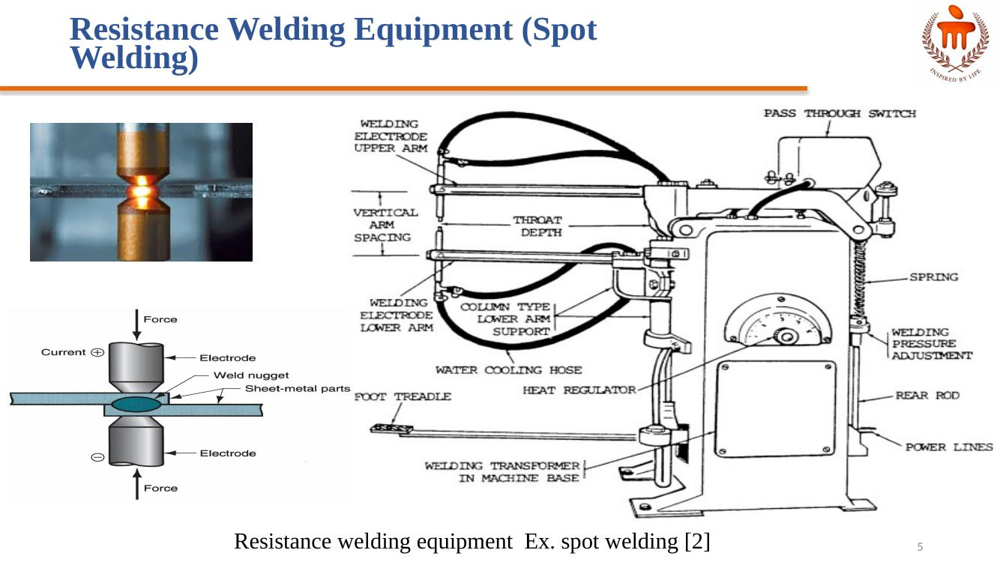
Figure: Resistance welding equipment (spot welding example)

References (as given in lecture)
- Ghosh, A. & Mallik, A.K.; Joining processes, Manufacturing Science, Latest edition.
- http://mewelding.com/resistance-welding-equipment/
- Kalpakjian, S & Schmid, S.; Manufacturing Processes for Engineering Materials, Latest edition.

Lecture 12 – Soldering and Brazing

🔥 HOT — Distinguish Between Brazing and Soldering
Brazing | Soldering
Melting point of the filler material is above 450°C | Melting point of the filler material is below 450°C
Dissimilar metals can be joined easily | Preferably similar metals can be joined
Good surface finish | Does not yield a good surface finish
Stronger joints | Less stronger joints

⚡ WARM — Brazing
Brazing is a method of joining two similar or dissimilar metals using a special fusible alloy. Brazing temperature is the range above the solidus temperature (where the filler metal begins to melt) and below the melting points of the base metals being joined. Generally, this ranges from approximately 450°C (842°F) to 1200°C (2192°F).

Brazing Heat Sources (Types of Brazing)
- Torch Brazing: uses a torch, often oxy-acetylene or propane, to heat the joint
- Induction Brazing: employs an induction coil to generate heat in the workpieces
- Furnace Brazing: involves placing the assembly in a furnace to heat it evenly
- Resistance Brazing: utilizes electrical resistance to create heat at the joint

Brazing Equipment
- Brazing Torch: a handheld tool for torch brazing
- Brazing Machine: used in induction or resistance brazing processes
- Nozzle Set: assorted nozzles for torches to control the flame
- Lighter / Spark Lighter: for igniting torches
- Gas Regulators & Hoses: for controlling gas flow in an oxy-acetylene setup
- Personal Protective Equipment (PPE): Brazing Goggles (protect eyes from sparks and fumes), Welding Gloves (shield hands from heat and sparks), Protective Clothing (e.g., leather aprons)

Brazing Process
- 1. Cleaning: thoroughly clean the components to remove oxides, grease, and other contaminants, as they can cause weak or brittle joints
- 2. Joint Design: create a joint with a precise, small gap (typically 0.05–0.2 mm) to facilitate capillary action for the filler metal
- 3. Fluxing: apply flux to prevent oxidation during heating and to promote wetting, allowing the filler metal to spread evenly
- 4. Heating: heat the assembled parts to a temperature just above the filler metal's melting point but below the melting point of the base metals
- 5. Applying Filler Metal: introduce the filler metal into the joint; it will melt and be drawn into the gap between the base metals by capillary action
- 6. Cooling: allow the assembly to cool, which solidifies the filler metal and creates a permanent, metallurgical bond
- 7. Post-Brazing: clean any remaining flux residue from the joint

⚡ WARM — Soldering
Soldering is a method of uniting two thin metal pieces using a dissimilar metal or an alloy by the application of heat.

Soldering Equipment
- Soldering Iron / Station: the heart of the operation, providing the heat to melt the solder; soldering stations offer temperature control and can be more versatile
- Solder Wire: the fusible metal alloy that creates the bond
- Soldering Iron Stand: a safe place to rest the hot soldering iron when not in use
- Wet Sponge: used to clean the soldering iron tip of excess solder and oxidation
- Desoldering Tools: tools like desoldering wick or a solder sucker help remove excess solder or correct mistakes

Soldering Types
- Soft solder: alloy of lead (37%) and tin (63%); melting temperature 150–350°C
- Hard solder: alloy of copper, tin, and silver; soldering temperature 600–900°C; used for stronger joints
- Flux: zinc chloride; cleans the joint surfaces and prevents oxidation

Soldering Process
- 1. Preparation: clean the surfaces (free from oil, dirt, or oxidation, using a solvent, fine sandpaper, or steel wool); position the components in their correct positions
- 2. Apply Flux: apply a flux pen or paste to the joint area; flux removes remaining oxide layers and prevents new ones from forming during heating, ensuring the solder flows properly and creates a good connection
- 3. Heat the Joint: heat the joint, not the solder — touch the heated tip of the soldering iron to the surfaces to be joined for a few seconds to bring them to soldering temperature, so they can melt the solder
- 4. Apply Solder: while the joint remains hot, bring the solder wire into contact with the heated joint; the heat from the joint melts the solder (not the iron); the molten solder flows into the joint, forming a strong bond
- 5. Finish the Joint: remove the iron and solder wire and allow the joint to cool and solidify; once cooled, clean any remaining flux residue with a damp sponge or cotton swab

⚡ WARM — Comparison of Soldering, Brazing and Welding
Soldering, Brazing | Welding
No direct melting of the base metals being joined | Direct melting of the base metals being joined
Useful for joining similar & dissimilar metals | Useful for joining similar metals
Brazing alloy and the solder have low melting points than the metals to be joined | Welding alloy has high melting point than the metals to be joined
Filler materials are solder and brazing alloy | Welding rod is used as filler material

References (as given in lecture)
- Ghosh, A. & Mallik, A.K.; Joining processes, Manufacturing Science, Latest edition.
- http://mewelding.com/resistance-welding-equipment/
- Kalpakjian, S & Schmid, S.; Manufacturing Processes for Engineering Materials, Latest edition.

Lecture 13 – Metal Forming: Introduction and Basics

⚡ WARM — Metal Forming Process
Metal Forming Process: a fabrication process in which parts/components are produced by subjecting the material to heavy plastic deformation.

⚡ WARM — Classification of Metal Forming
Metal forming is broadly divided into Bulk Deformation processes and Sheet Metalworking processes.
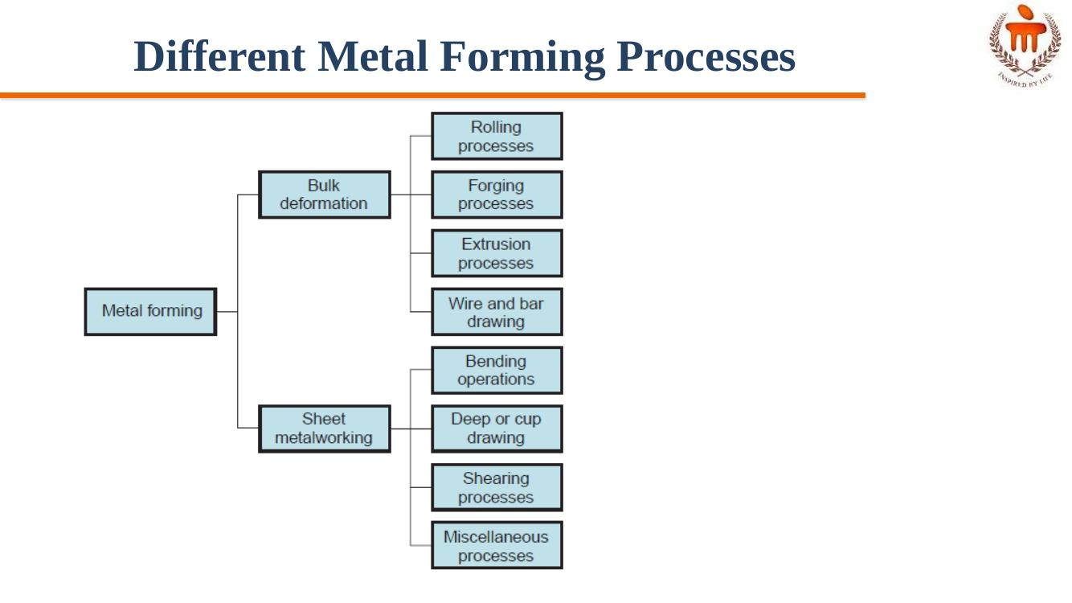
Figure: Classification of metal forming — bulk deformation vs sheet metalworking
- Bulk Deformation: Rolling processes, Forging processes, Extrusion processes, Wire and bar drawing
- Sheet Metalworking: Bending operations, Deep or cup drawing, Shearing processes, Miscellaneous processes

🔥 HOT — Hot Working vs Cold Working

Hot Working Processes
- The bulk deformation process occurs above the recrystallization temperature
- Strength and hardness decrease because of recrystallization
- Carried out at a higher temperature, but lower than the melting temperature (0.5 Tm to 0.75 Tm)
- New crystals are formed due to recrystallization, which are strain-free
- No residual stresses
- Surface finish is not good
- Less force is required
- Advantages: significant plastic deformation possible; significant change in workpiece shape; lower forces required; materials with premature failure can be hot formed; absence of strengthening due to work hardening
- Disadvantages: shorter tool life; poor surface finish; lower dimensional accuracy; sample surface oxidation

Cold Working Processes
- The bulk deformation process occurs below the recrystallization temperature
- Strain hardening leads to an increase in strength and hardness
- Ductility decreases
- Internal/residual stresses set up in the material
- No new crystal forms
- Surface finish can be achieved
- More force and power are required

Warm Working Process
- Forming is performed at temperatures just above room temperature but below the recrystallization temperature
- The working temperature is taken to be 0.3 Tm, where Tm is the melting point of the workpiece
- Advantages: enhanced plastic deformation properties; lower forces required; intricate work geometries are possible; annealing stages can be reduced

💧 POSSIBLE — Bulk Forming Processes
- Rolling: the workpiece in the form of a slab or plate is compressed between two rotating rolls in the thickness direction, so that the thickness is reduced; the rotating rolls draw the slab into the gap and compress it; the final product is in the form of a sheet
- Forging: the workpiece is compressed between two dies containing shaped contours; the die shapes are imparted to the final part
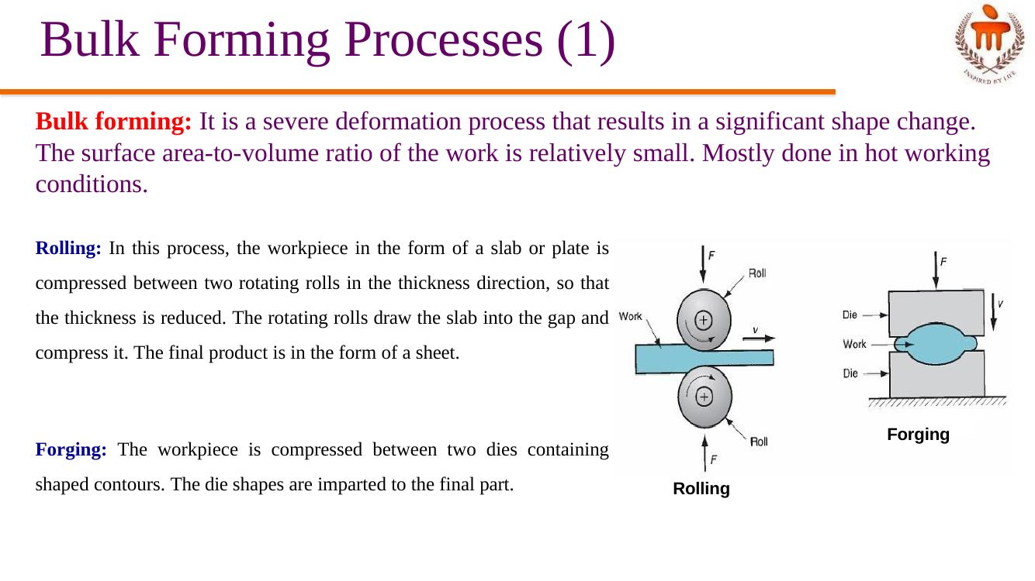
Figure: Rolling and Forging schematics
- Extrusion: the workpiece is compressed or pushed into the die opening to take the shape of the die hole as its cross-section
- Wire or rod drawing: similar to extrusion, except that the workpiece is pulled through the die opening to take the cross-section
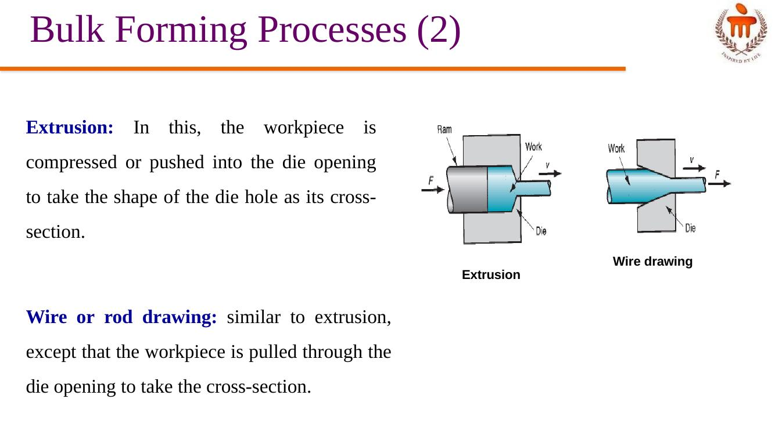
Figure: Extrusion and wire drawing schematics

💧 POSSIBLE — Sheet Metal Forming Processes
- Sheet metal forming involves forming and cutting operations performed on metal sheets, strips, and coils
- The surface area-to-volume ratio of the starting metal is relatively high
- Punches and dies are used as tools to deform the sheets
- Bending: the sheet material is strained by a punch to give a bend shape (angle shape) usually in a straight axis
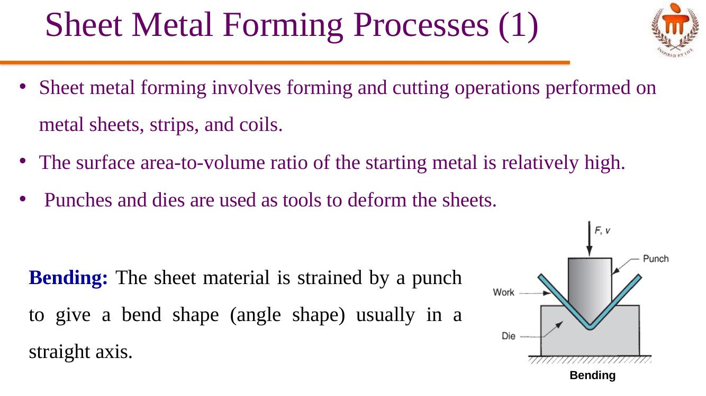
Figure: Bending operation
- Deep (or cup) drawing: forming a flat metal sheet into a hollow or concave shape, such as a cup, is achieved by stretching the metal in specific regions; a blank holder is used to clamp the blank against the die, while the punch pushes into the sheet metal; the sheet is drawn into the die hole, taking the shape of the cavity
- Shearing: cutting of sheets by shearing action
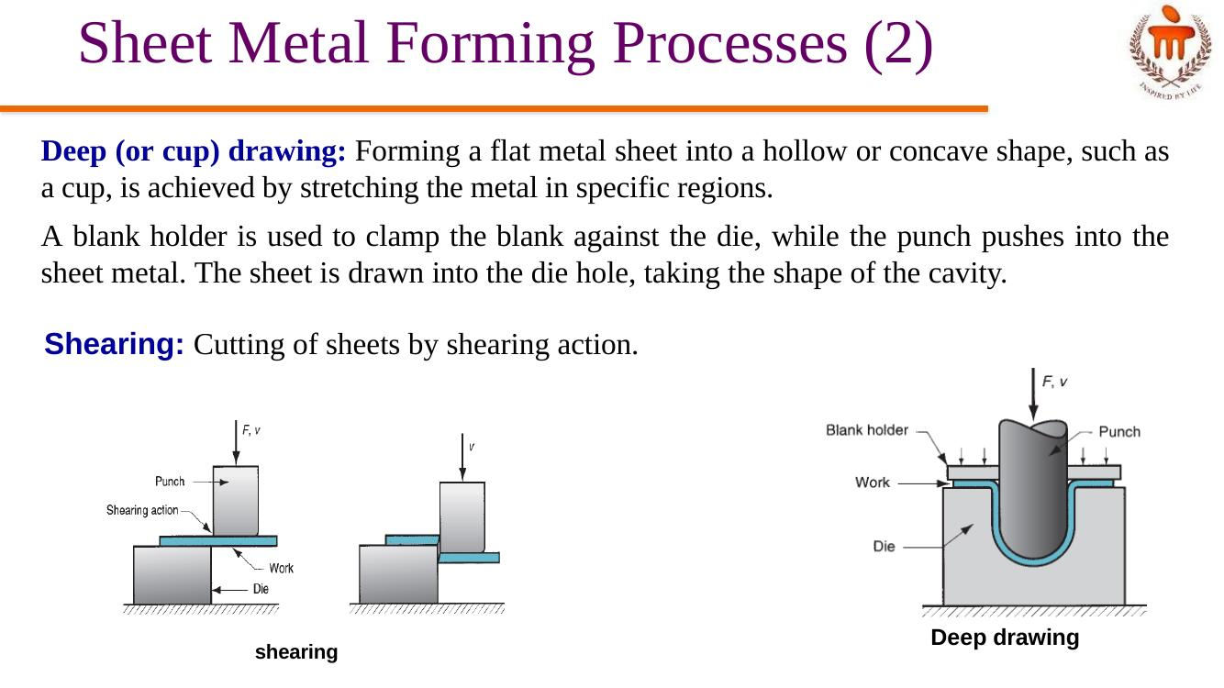
Figure: Shearing and Deep drawing operations

Lecture 14 – Rolling and Forging

🔥 HOT — Rolling Process & Terminology
Rolling is a metal forming process in which the thickness of the work is reduced by compressive forces exerted by two rolls rotating in opposite directions.
- Bloom: square cross-section, 150 mm × 150 mm or more
- Slab: rolled from an ingot or a bloom; rectangular cross-section of 250 mm width or more and a thickness of 40 mm or more
- Billet: rolled from a bloom; square in cross-section with dimensions 40 mm on a side or more

🔥 HOT — Rolling Mills (Two-High)
- Two High Rolling Mill: consists of two rolls rotating in opposite directions; roll diameters 0.6 to 1.4 m; types: reversing or non-reversing
- Non-reversing mill: rolls rotate only in one direction, and the slab always moves from the entry to the exit side
- Reversing mill: direction of roll rotation is reversed after each pass, so the slab can be passed through in both directions; permits continuous reductions to be made through the same pairs of rolls
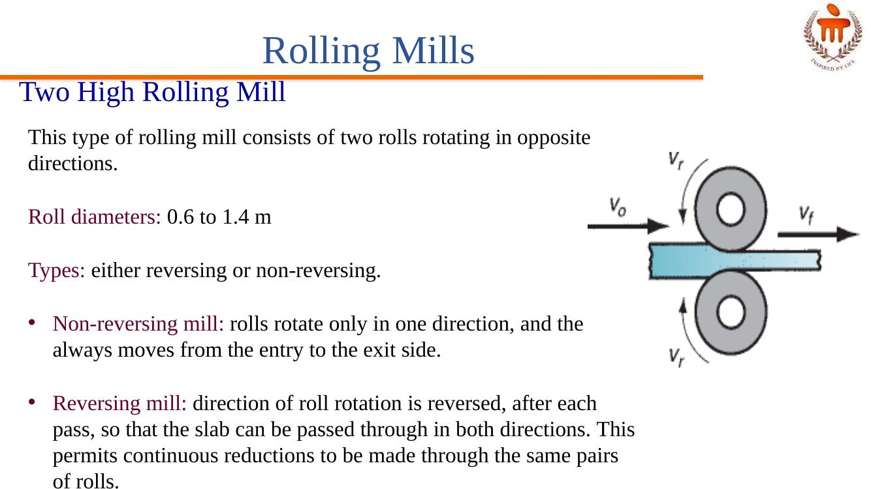
Figure: Two high rolling mill

⚡ WARM — Rolling Process Applications
- Blooms are rolled into structural shapes like rails for railroad tracks
- Billets are rolled into bars, rods — raw materials for machining, wire drawing, forging, and extrusion
- Slabs are rolled into plates, sheets, and strips; hot-rolled plates are used in shipbuilding, bridges, boilers, and welded structures for heavy machinery
- Plates and sheets are further reduced in thickness by cold rolling to strengthen the metal and permit a tighter tolerance on thickness

⚡ WARM — Other Rolling Mills (Three-High, Four-High, Cluster, Tandem)

Three High Rolling Mill
- For a single pass, two rolls are used
- The roll direction cannot be changed
- The top two rolls are used for the first reduction, and the sheet is shifted to the bottom two rolls for further reduction
- Disadvantage: an automated mechanism is required to shift the slab

Four High Rolling Mill
- Consists of two small rolls for thickness reduction and two large backing rolls to support the small rolls
- The small rolls reduce the roll force required as the roll-sheet contact area is reduced
- The large backing rolls reduce the elastic deflection of small rolls when the sheet passes between them
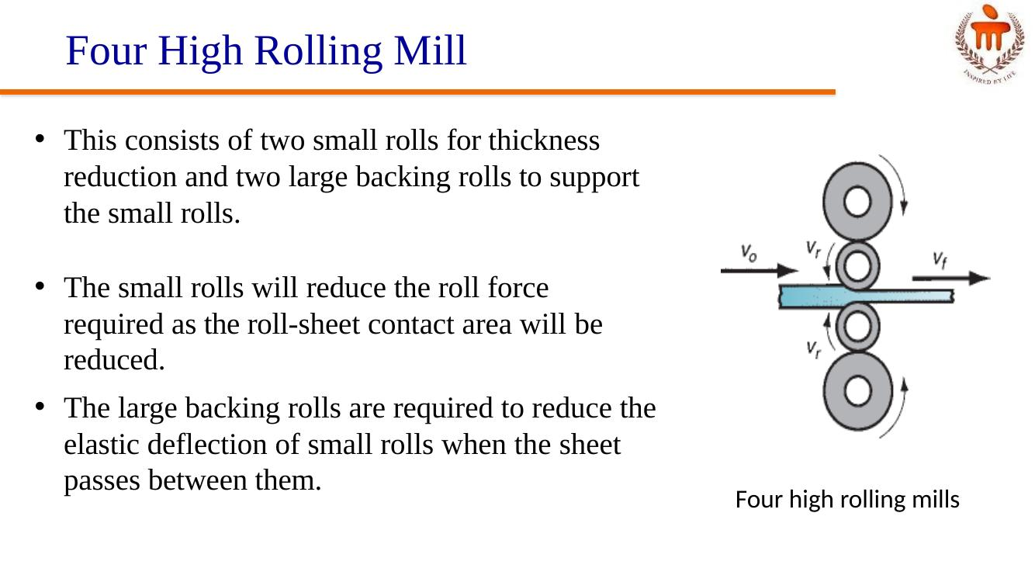
Figure: Four high rolling mill

Cluster and Tandem Rolling Mills
- Cluster rolling mills use small rolls for rolling purposes
- Tandem Rolling Mill: consists of a series of rolling stations of the order of 8 to 10; in each station, thickness reduction is given to the sheet; with each rolling station, the work velocity increases; fully used in industry practice along with the continuous casting operation; results in reduction in floor space and shorter manufacturing lead time
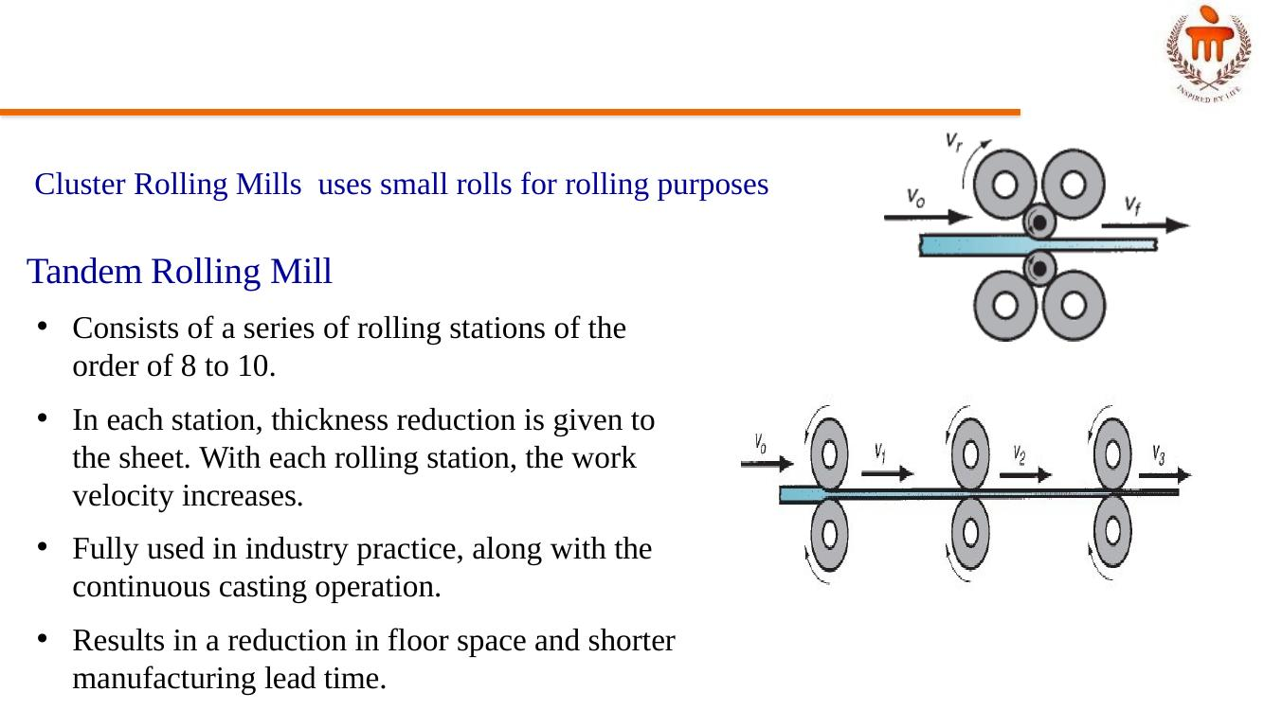
Figure: Cluster rolling mill and Tandem rolling mill

⚡ WARM — Classification of Forging
Forging is a deformation process in which the workpiece is compressed between two dies, using either impact load or hydraulic (gradual) load to deform it. Used to make high-strength components: engine crankshafts, connecting rods, gears, aircraft structural components, jet engine turbine parts.
- Based on temperature: (a) cold forging, (b) warm forging, (c) hot forging
- Based on presses: (a) impact load → forging hammer; (b) gradual pressure → forging press
- Based on type of forming: (a) Open die forging, (b) Impression die forging, (c) Flashless forging
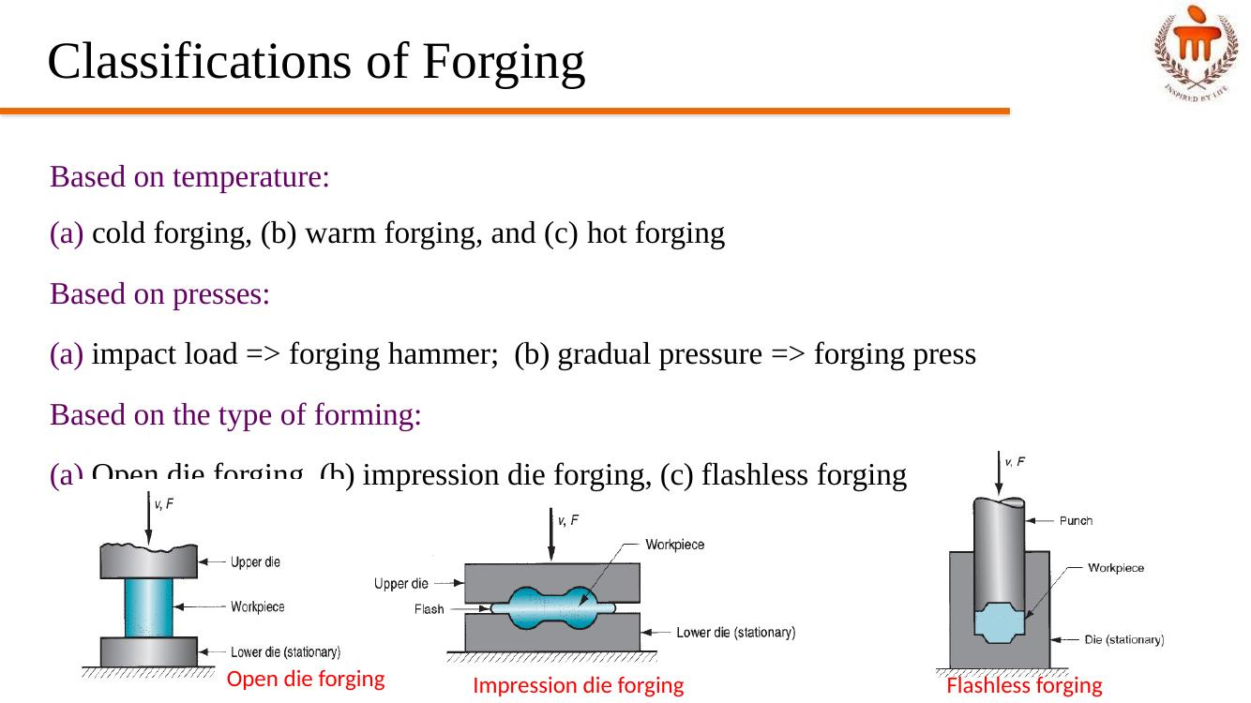
Figure: Open die, Impression die, and Flashless forging compared

⚡ WARM — Open Die Forging
A simple example of open die forging is the compression of a billet between two flat die halves, like a compression test — also known as upsetting or upset forging. Under ideal conditions, with no friction between the billet and die surfaces, homogeneous deformation occurs — the diameter increases uniformly throughout its height.
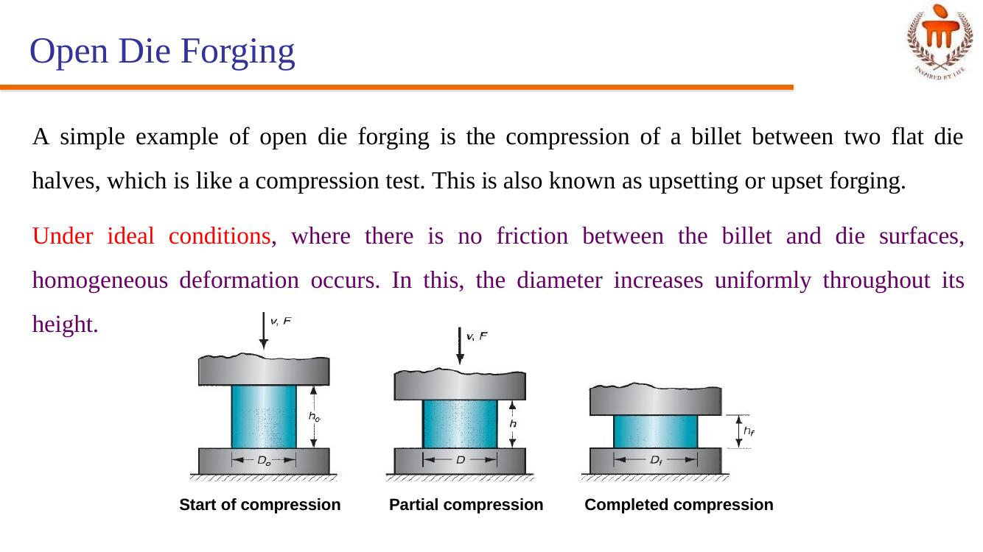
Figure: Open die forging — start, partial, and completed compression

💧 POSSIBLE — Impression Die (Closed Die) Forging
- Performed in dies which have the impression that will be imparted to the workpiece through forming
- In the intermediate stage, the initial billet deforms partially, giving a bulged shape
- During die full closure, the impression is fully filled with the deformed billet and further moves out of the impression to form flash
- In a multi-stage operation, separate die cavities are required for shape change
- When drop forging is used, several blows of the hammer may be required for each step
- Example: Coining

💧 POSSIBLE — Flashless Forging
- The workpiece volume must equal the space in the die cavity within a very close tolerance
- If the starting billet size is too large, excessive pressures will cause damage to the die and press; if too small, the cavity will not be filled
- Suitable to make simple and symmetrical part geometries, and to work with materials such as Al, Mg, and their alloys

Lecture 15 – Extrusion and Wire/Tube Drawing

⚡ WARM — Types of Extrusion (Direct & Indirect)
Extrusion: a bulk forming process in which the work metal is forced or compressed to flow through a die hole to produce a desired cross-sectional shape. Example: squeezing toothpaste from a toothpaste tube.
- Advantages: a variety of shapes are possible, especially using hot extrusion; grain structure and strength properties are enhanced in cold and warm extrusion; close tolerances are possible, mainly in cold extrusion

Direct (Forward) Extrusion
- A metal billet is first loaded into a container having die holes
- A ram compresses the material, forcing it to flow through the die holes
- Extra portion of the billet left at the end that cannot be extruded is called the butt; separated from the product by cutting it just beyond the exit
- Hollow sections like tubes can be made using direct extrusion — starting billet is prepared with a hole parallel to its axis, and material flows through the gap between the mandrel and the die opening
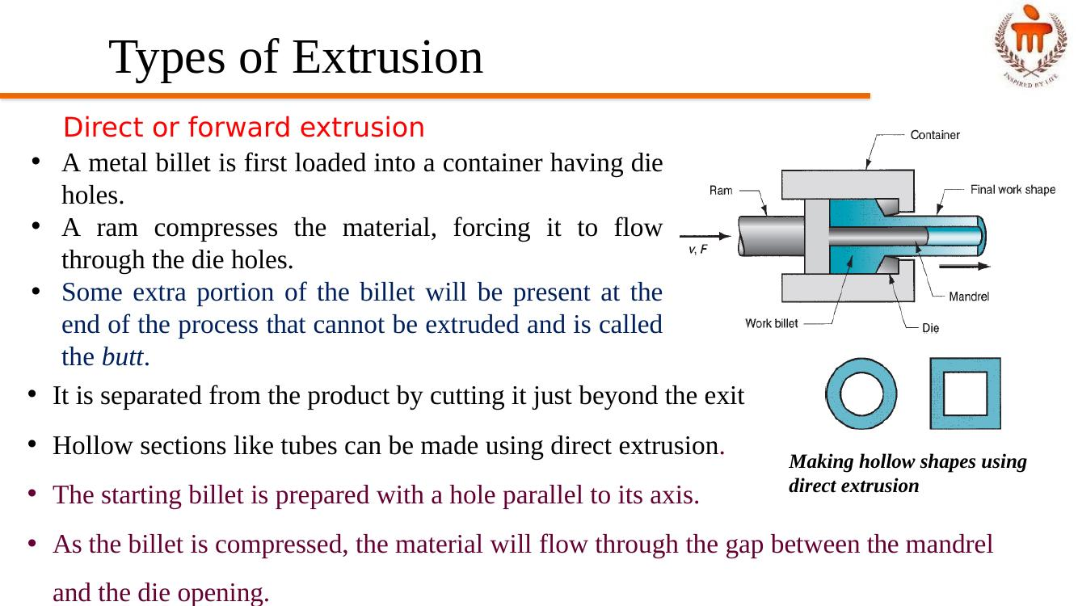
Figure: Direct (forward) extrusion, including hollow-shape variant

Indirect Extrusion
- The die is mounted to the ram and not on the container
- As the ram compresses the metal, it flows through the die hole on the ram side, opposite to the direction of ram movement
- No relative motion between billet and container — no friction at the interface, hence ram force is lower than in direct extrusion
- Limitations: lower rigidity of the hollow ram; difficulty in supporting the extruded product at the exit
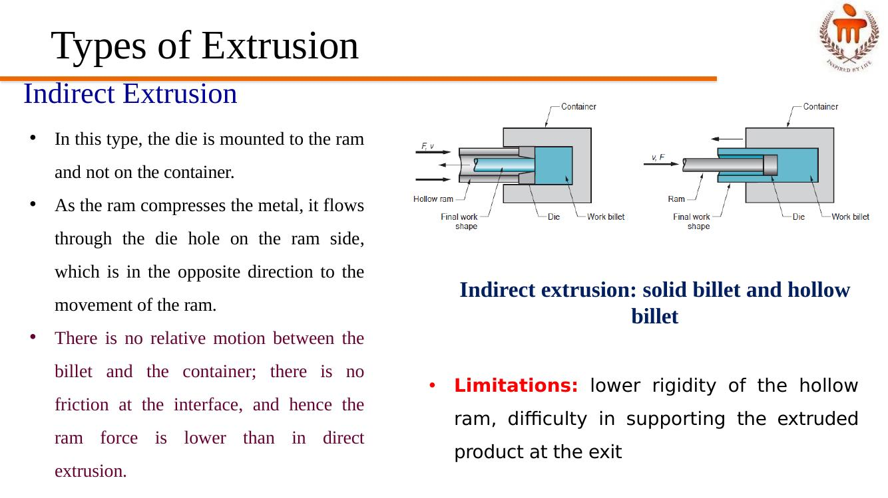
Figure: Indirect extrusion — solid billet and hollow billet

💧 POSSIBLE — Other Extrusion Processes

Impact Extrusion
- Performed at higher speeds and shorter strokes; the billet is extruded through the die by impact pressure and not just by applying pressure
- Can be carried out as forward extrusion, backward extrusion, or a combination
- Carried out as cold forming; very thin walls possible by the backward impact extrusion method
- Examples: toothpaste tubes, battery cases
- Advantages: large reductions and high production rates

Hydrostatic Extrusion
- The billet is surrounded with fluid inside the container, and the forward motion of the ram pressurizes the fluid
- No friction inside the container because of the fluid; friction minimized at the die opening
- In the absence of friction, hydrostatic pressure on the work increases the material's ductility
- Can be used on metals too brittle for conventional extrusion; also applicable for ductile metals, with high reduction ratios possible
- The billet must be formed with a taper at one end to fit tightly into the die entry angle

💧 POSSIBLE — Wire, Rod, Bar Drawing
A wire, rod, or bar is pulled through a die hole, reducing its cross-sectional area.
- Bar drawing: meant for large diameter bar and rod; done as a single-stage operation in which stock is pulled through one die opening; inlet bars are straight (not coiled), limiting the length of work that can be drawn
- Wire drawing: meant for small diameter stock (down to ~0.03 mm); wire is drawn from coils through a series of 4 to 12 dies; called "continuous drawing" because of the long production runs achieved; segments can be butt-welded to the next to make the operation truly continuous

💧 POSSIBLE — Tube Drawing
- Used to reduce the diameter or wall thickness of seamless tubes and pipes
- Can be done either with or without a mandrel
- Tube sinking (no mandrel): the simplest method; used for diameter reduction; inside diameter and wall thickness cannot be controlled
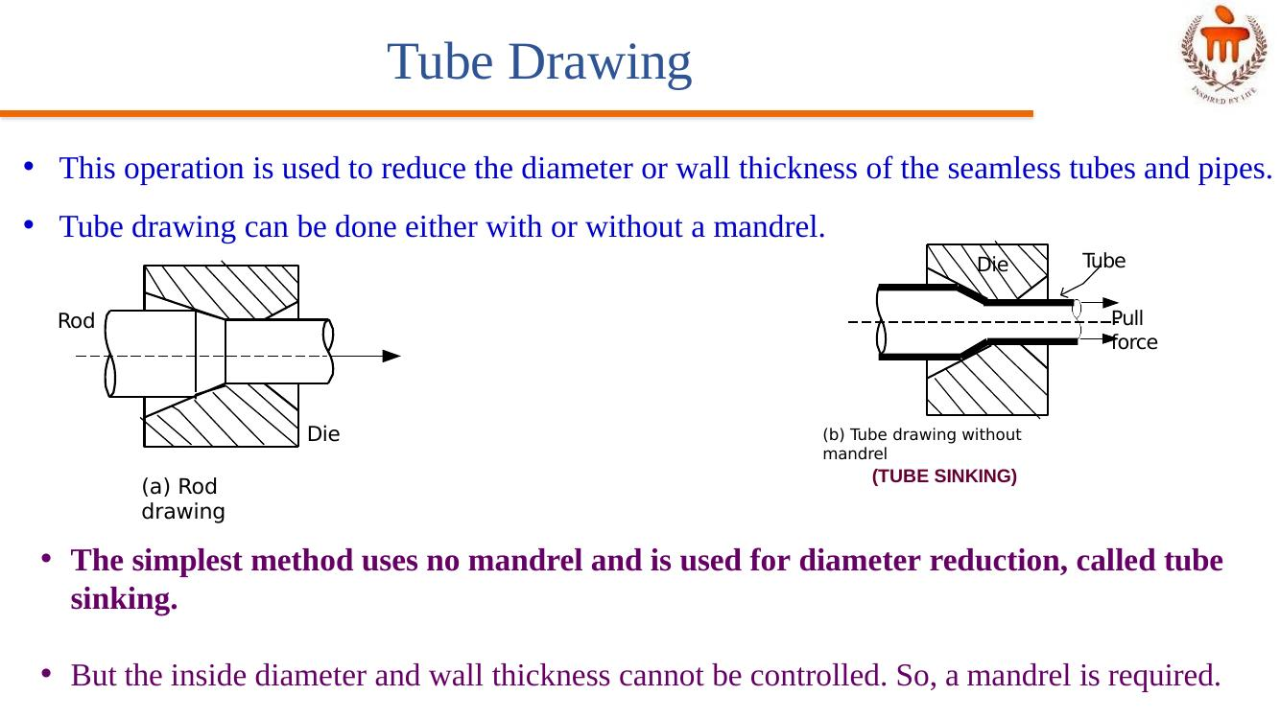
Figure: Rod drawing and Tube drawing without mandrel (tube sinking)
- Fixed mandrel: a mandrel attached to a long support bar controls the inside diameter and wall thickness; the length of the support bar restricts the length of tube that can be drawn
- Floating plug: the mandrel floats inside the tube and finds a suitable position in the reduction zone of the die; no length restriction, unlike with the fixed mandrel

Lecture 16 – Sheet Metal Forming

🔥 HOT — Blanking and Punching
- Blanking: sheet metal cutting to separate a piece (called a blank) from the surrounding stock — the blank is the desired part; the surrounding sheet becomes scrap
- Punching: a metal fabricating process that removes a scrap slug from the metal workpiece each time a punch enters the punching die; this process leaves a hole in the metal workpiece
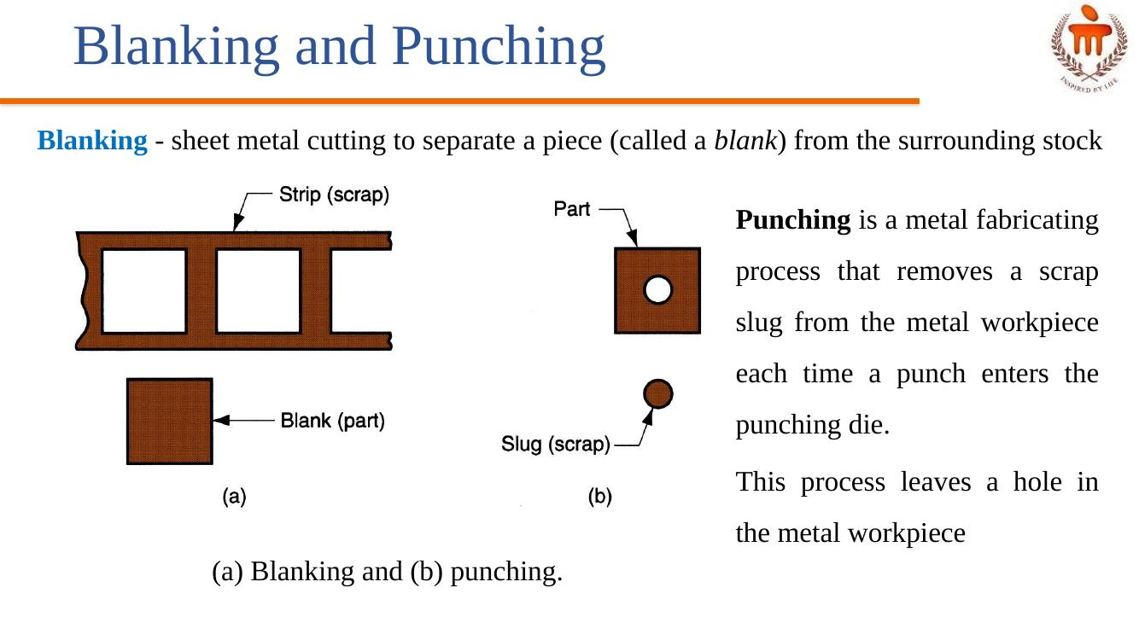
Figure: (a) Blanking and (b) Punching

Punching and Piercing
- Punching: no slug is cut, only burr
- Piercing: slug is cut and the burr is minimal; pierced holes have a significantly more pronounced burr than punched material

⚡ WARM — Drawing (Deep Drawing)
- Sheet metal forming to make cup-shaped, box-shaped, or other complex-curved, hollow-shaped parts
- The sheet metal blank is positioned over the die cavity, and the punch pushes the metal into the opening
- Also known as deep drawing (to distinguish it from wire and bar drawing)
- Products: beverage cans, ammunition shells, automobile body panels

Stages in Deep Drawing
- Stage I: as the punch pushes the sheet, it is subjected to a bending operation; bending occurs over the punch corner and the die corner; the outside perimeter of the blank moves slightly inwards toward the cup center
- Stage II: the sheet region bent over the die corner is straightened in the clearance region, becoming a cup wall region; more metal is pulled from the sheet edge to compensate, i.e., more metal moves into the die opening
- Stage III: friction between the sheet and the die/blank holder surfaces restricts movement of the sheet into the die opening; the blank holding force also influences the movement; lubricants or drawing compounds are used to reduce friction forces
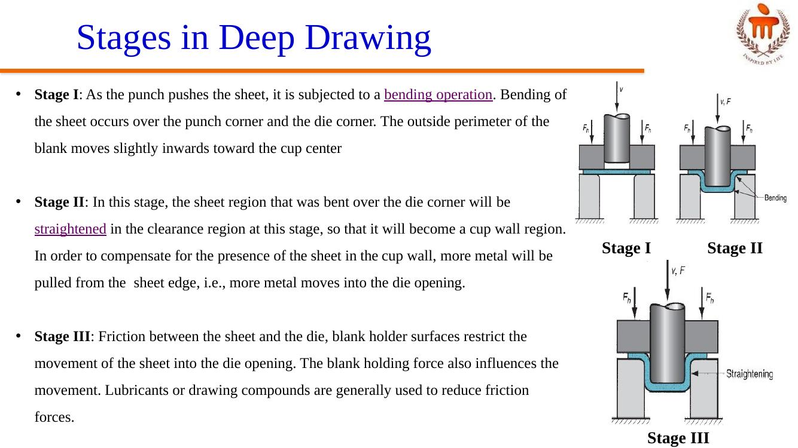
Figure: Stages I–III in deep drawing
- Stage IV: compression occurs at the edge of the sheet; since the perimeter is reduced, the sheet is squeezed into the die opening; because volume remains constant, thickening occurs at the edge; in thin sheets this shows as wrinkling — low blank holding force (BHF) causes wrinkling, while high BHF prevents proper flow, causing stretching and tearing
- Stage V: the final cup part will have some thinning in the side wall

💧 POSSIBLE — Sheet Metal Forming Operations (Overview)
Sheet metal forming involves the plastic deformation of sheets.
- Shearing / Cutting: shearing to separate large sheets; blanking to cut part perimeters out of sheet metal; punching/piercing to make holes in sheet metal
- Bending: straining sheet around a straight axis
- Drawing: forming of sheet into convex or concave shapes

💧 POSSIBLE — Shearing
- Sheet metal cutting operation along a straight line between two cutting edges
- Typically used to cut large sheets
- Engagement of the entire blade into cutting requires higher forces; therefore, an inclined blade is used to reduce force and improve the cut-edge
- Shearing stages: (1) just before the punch contacts work; (2) punch begins to push into work, causing plastic deformation; (3) punch compresses and penetrates into the work, causing a smooth cut surface; (4) fracture is initiated at the opposing cutting edges, which separates the sheet
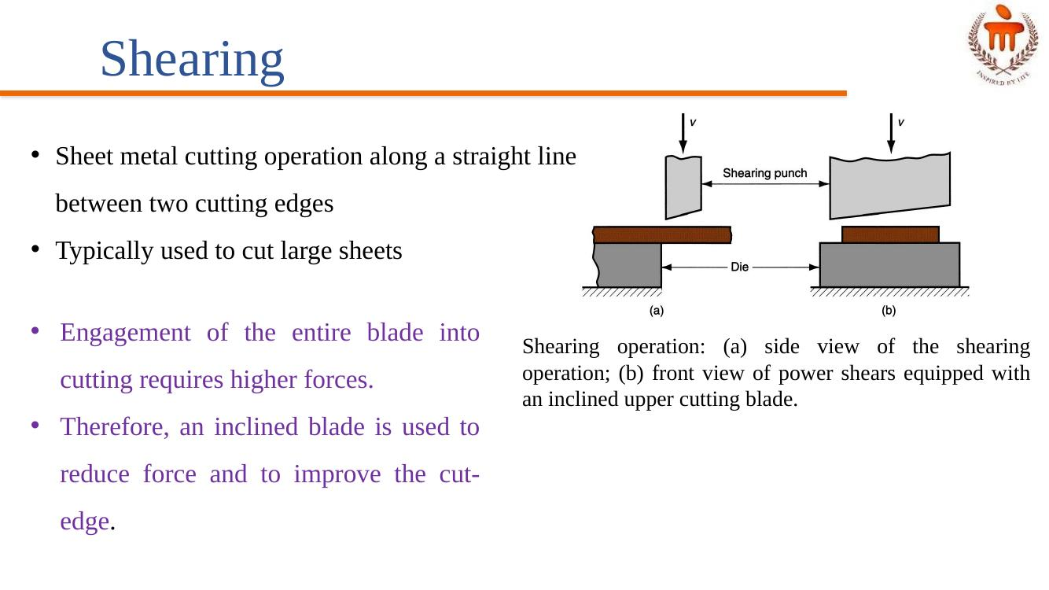
Figure: Shearing operation — side view and power shears with inclined blade

💧 POSSIBLE — Types of Sheet Metal Bending
- V-bending: performed with a V-shaped die; for low production; performed on a brake press; V-dies are simple and inexpensive
- Edge bending: performed with a wiping die; for high production; pressure pad required; dies are more complicated and costly
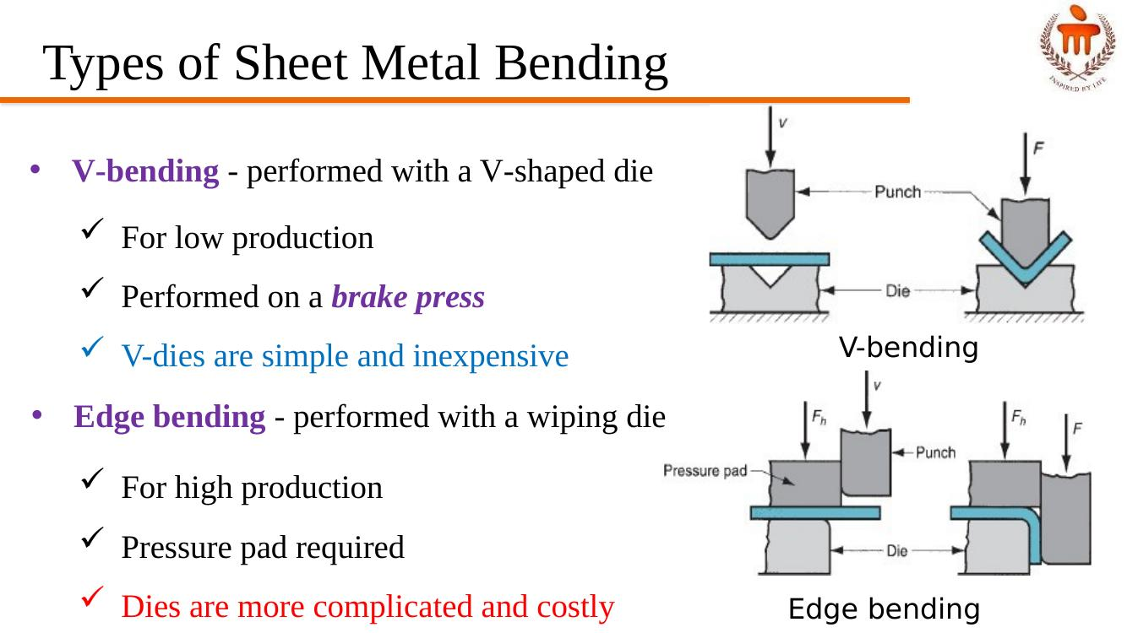
Figure: V-bending and Edge bending

Stretching during Bending
- If the bend radius is small relative to the stock thickness, the metal tends to stretch during bending
- Important to estimate the amount of stretching, so the final part length can meet the specified dimension

